COM 415
Style Used: MLA

Near-Past Nostalgia: How Recycling of Recent Culture Reshapes Collective Memory and Generational Identity

Abstract
In late 2025, a viral question circulated across social media: “Will this be the new 2016?” On platforms such as TikTok and Instagram, users began reposting songs, aesthetics, memes and editing styles associated with 2016, not simply as nostalgia, but as a collective effort to reconstruct that year as a meaningful cultural reference point for the present. This paper draws on collective memory theory to examine how recycled digital culture functions as a communicative mechanism for producing shared memory and generational identity. Integrating the work of Oren Meyers, Pierre Nora, Andrew Hoskins, Katharina Niemeyer, and Emily Keightley and Michael Pickering, the study argues that repetition, remixing, and platform-driven visibility allow fragments of the near past to be reassembled into recognizable symbols that stand in for an entire cultural moment. Using qualitative content analysis of highly viewed TikTok posts and their comment sections, the study identifies recurring visual styles, audio clips, phrases, and trends that users repeatedly reference as markers of “2016 culture.” The findings show that users are less concerned with historical accuracy than with shared recognition, emotional tone, and participatory banter. Through likes, comments, hashtags, and remix features, certain details gain dominance and begin to define the year itself. This process reflects how collective memory in digital spaces is sustained through circulation rather than preservation, where engagement metrics and platform design shape what remains culturally visible. The resurgence of 2016 is interpreted as a post-pandemic effort by Gen Z to construct a shared point of reference that provides emotional stability and identity continuity. Ultimately, the paper argues that in digital environments, memory operates not as retrieval of the past but as an active, communicative resource used to make sense of the present.
End of abstract

Every time the year is coming to an end, we know people gravitate towards two emotions: gratitude or guilt. They are either proud of their accomplishments, or regret things not going the way they planned. Both of these emotions make way for bigger expectations in the coming year, and for most of the population, these expectations are superficial. There’s worry about things like, “What are we wearing this year?” “What brands are we supporting?” “What music are we listening to?” “What will be the new best thing?” That was slightly shifted in December 2025. The expectation for 2026 expressed on social media platforms was, “Will this be the new 2016?”
All over social media, posts were made using audio clips from songs, dance moves, clothing and memes, that were originally popularized in 2016. These posts did more than simply revisit the past, they framed it as something recognizable, meaningful and worth returning to. As the year 2026 began, users weren’t just remembering 2016; they were collectively reconstructing it through repeated references and participation. It seemed to be mainly the older and middle Gen Z age group (those born between 1997 and 2005), or the generation who was experiencing adolescence in that year, who was engaging most. However, even those who may not have fully experienced that moment, engaged with it. In this way, understanding the past became less about personal experience and more about shared recognition.
This wave of content reflects a larger shift in how memory operates in digital spaces. Collective memory theory argues that memory is not an individual process, but a social one shaped through communication and public discourse (Meyers 318). Instead of relying on historical distance, the past is reproduced through visibility and repetition. Platforms like TikTok and Instagram make it easy for cultural fragments to resurface because their algorithms prioritize recirculation and remixing of familiar content, allowing the memory placed in this medium to be actively constructed through mediated interactions.
The question, “Will this be the new 2016?” reveals more than a desire for trends to return. It reflects a need for a shared cultural moment. As collective memory theory suggests, reviving the recent past forms shared understandings of the past, which emerge not from accuracy, but from repetition and communicative reinforcement (Meyers 320). In this way, nostalgia on social media becomes a tool for constructing generational identity, defining not only how the past is remembered but how the present is experienced.
This paper draws on collective memory theory to explore how recycled digital culture, particularly memes and recurring aesthetic trends, functions as a contemporary mechanism for the communicative construction of shared memory.
Literature Review
Collective memory scholarship emphasizes that remembering is a social process shaped by communicative circulation and public negotiation. Clinical Psychiatrist Oren Meyers explains that collective memory emerges through discussion that stabilizes certain interpretations while marginalizing others, distinguishing it from personal recollection by its popularity and institutional reinforcement (Meyers 318). By “institutional,” Meyers refers to systems of communication such as media organizations, archives and, in contemporary contexts, digital platforms. These structures do not simply preserve memory; They give certain narratives durability by making them more visible and repeatable than others. Memory becomes “collective” not because everyone remembers identically, but because particular narratives gain legitimacy through repetition (Meyers 320). This emphasis on discourse situates collective memory firmly within communication theory.
Historian, Pierre Nora’s concept of “lieux de mémoire” or “sites of memory” further develops this framework by arguing that modern societies depend on symbolic sites when people no longer feel a direct, ongoing connection to the past through their everyday lives (Nora 7). In these moments, remembrance becomes attached to mediated forms that organize and frame selected pieces of history (Nora 12). Although Nora identified archives, texts and commemorative spaces as said sites, the concept can be extended to digital environments, where platforms operate as dispersed yet powerful locations of memory.
In the case of 2016 nostalgia, TikTok videos, trending audios and visual aesthetics act as modern “sites of memory,” anchoring collective recognition of that year. These spaces do not merely preserve the past; they define what is or was recognizable, meaningful and culturally legible. While Meyers emphasizes how discourse legitimizes certain narratives, Nora highlights the structural need for symbolic anchors that give those narratives durability. Together, their work shows that memory persists not through passive inheritance but is actively built through communication and the spaces that support it.
The role of media becomes more pronounced when considering theories of social construction. Professors of Media, Communications and Social Theory, Nick Couldry and Andreas Hepp, argue that social reality itself is shaped through communicative infrastructures that determine what becomes visible and legitimate within public life (Couldry and Hepp 126). If media shapes how we understand the present, it also shapes how we understand the past. Their work complements collective memory theory by showing that social media does not simply transmit information, but it also helps shape how people interpret meaning (Couldry and Hepp 130). Public understanding of prior events cannot be separated from the communicative environments in which narratives circulate.
Digital media can intensify these dynamics by altering the temporal and structural conditions under which shared remembrance operates. Researcher, Andrew Hoskins describes this shift as the “connective turn,” in which networked communication collapses temporal distance and integrates prior and present moments within continuous streams of interaction (“Media, Memory, Metaphor” 20). Unlike traditional archives that imply permanence, digital environments are characterized by immediacy and constant reactivation (“Digital Network Memory” 90).
The research of Adriaansen and Smit explains that social media allows the past to be constantly reshaped through ongoing sharing and interaction, rather than simply stored as something fixed (Adriaansen and Smit 1). The quick return of 2016 trends shows this clearly, as content from about a decade ago is recirculated and experienced as both past and present at the same time. Hoskins suggests that repetition, rather than permanence, is what keeps meaning alive in digital spaces. Hoskins’s account complicates earlier formulations by suggesting that stability is no longer achieved through monumentality but through circulation. Repetition replaces permanence as the mechanism through which meaning is sustained. Over time, small and easily recognizable details begin to represent entire periods. Items such as specific slang phrases, color palettes, camera filters or editing styles can symbolize a broader cultural moment. These fragments gain importance not because they fully represent the time, but because they are simple to recognize and reproduce.
Platform design intensifies this pattern. Algorithmic recommendation feeds, searchable hashtags and remix features prioritize content that already shows familiarity and engagement. The more a visual style or reference is reused, the more likely it is to appear again in users’ feeds. This creates a cycle in which certain cultural pieces are repeatedly surfaced while less adaptable aspects of the past receive little attention. What endures is shaped not only by participation but also by the technical systems that reward repetition.
For example, when users begin applying the same vintage-style filter or editing preset to their videos, the platform’s visual similarity detection and engagement metrics push these videos to wider audiences. Viewers then adopt the same style, reinforcing its visibility. Through this process, an editing choice becomes associated with a specific era, even if it was only one small part of it. Collective memory in digital spaces therefore becomes tied to both social interaction and the technological structures that determine what is most easily seen and repeated (Hoskins, “Digital Network Memory” 97).
Nostalgia introduces an additional dimension to this process. Professor of Media Theory, Katharina Niemeyer argues that mediated nostalgia reshapes the relationship to the past and present by producing emotionally resonant representations of prior moments (Niemeyer 1221). Rather than simple longing, nostalgia reframes time by stylizing selected fragments of history. Professors Emily Keightley and Michael Pickering use the term “mnemonic imagination” to describe the process through which the past is actively reworked rather than simply recalled. It refers to how individuals and groups assemble fragments of earlier experience into new meanings that fit present contexts. This process links memory to identity by shaping how people understand themselves through reconstructed versions of prior moments (Keightley and Pickering 117). Both perspectives align with collective memory theory by emphasizing interpretive framing rather than retrieval. The past or “near past” is reconstructed through communication rather than accessed intact.
Cultural artifacts from the 2010s, childhood media, or earlier social platforms are revived and treated as artifacts of a completed era. Through stylization and repetition, recent experiences are reclassified as “retro.” Niemeyer’s argument that media reshapes temporal perception clarifies how this transformation occurs (Niemeyer 1221). Keightley and Pickering’s emphasis on imaginative reconstruction further explains how even brief temporal gaps can produce nostalgic framing (Keightley and Pickering 117). Networked platforms accelerate this process by rapidly converting lived experience into shareable fragments (Hoskins, “Media, Memory, Metaphor” 23). What was immediate becomes recognizable as historical through communicative repetition.
Across these theories, a few key ideas emerge: Memory is not something people simply store, it is shaped through communication, repetition and shared recognition (Meyers 318; Couldry and Hepp 126). It relies on symbols and media to make the past visible and meaningful (Nora 7), and in digital spaces, this process happens through constant circulation rather than long-term preservation (Hoskins, “Digital Network Memory” 90). Nostalgia further reshapes this process by reframing how time is experienced, often turning recent moments into something that feels distant or culturally significant (Niemeyer 1221; Keightley and Pickering 117).
Despite these insights, little work has been done that integrates collective memory theory with analyses of recycled digital culture. Research on shared remembrance often centers on national identity, trauma, or institutional archives (Meyers 322; Nora 8), while digital media studies frequently focus on virality or platform design without grounding analysis in memory theory (Hoskins, “Digital Network Memory” 92). The intersection of these fields, particularly how repetition, remixing, and revived trends function as decentralized mechanisms of shared remembrance, remains underexamined. Existing literature establishes that meaning is shaped through mediation and repetition, yet it has not fully addressed how digital recirculation itself operates as a primary mnemonic, or memory-based, practice.
Taken together, this research suggests that in digital spaces, things stay meaningful not because they last, but because they keep reappearing. Recirculated content gains significance through repetition, reinterpretation, and emotional framing. Further theoretical exploration is necessary to examine how recycled digital trends and memes operate within collective memory frameworks, functioning as communicative processes through which contemporary publics negotiate shared understandings of time and identity.
Research Questions
- What role do social media platforms play in shaping collective memory around recent cultural pasts?
- How does the revival of 2016 trends reflect generational identity and changing cultural meanings over time?

Methods
Over the course of this research, I will collect and analyze a sample of TikTok posts that reference 2016, focusing on trends, captions and user comments. I will identify recurring elements such as specific audio clips, visual styles, phrases and themes that signal “2016 culture.” Then, I will examine how these elements are repeated, modified and engaged with across posts to see how they become recognizable and shared. I will also analyze captions and comments to understand how users interpret and reinforce these references, paying attention to patterns in language, humor and emotional tone. By tracking these patterns, I aim to show how repeated content and interaction turn individual posts into a broader, shared understanding of 2016.
Posts are selected based on clear references to 2016, such as specific sounds, aesthetics, or captions that frame the content as part of that time. While selection is subjective, examples are chosen for how well they reflect broader patterns of circulation. I would like to preface that all of the videos I am using have at least 200,000 views each. In order for this analysis to work, I selected the most viral videos on the 2016 “resurgence.” From the most viral videos, I have selected the most popular comments; these were the most liked, or the ones that started the longest comment thread under the video.
This approach aligns with Meyers’ argument that collective memory forms through repeated public discussion, where certain interpretations gain visibility and legitimacy (Meyers 318). In these spaces, engagement metrics such as likes, comments, shares, saves and reposts operate as visibility cues that shape how content is distributed and sustained within platformed communication systems, affecting which cultural references continue to circulate.
The analysis examines how repetition, visibility and engagement shape meaning. Drawing on Hoskins’ concept of the “connective turn,” it considers how networked media makes the near-past feel present by repeatedly reactivating past content within ongoing digital streams. Adriaansen and Smit further support this by showing how social media enables the past to be continuously reshaped through interaction. Together, these frameworks help explain how 2016 is not just remembered but actively reconstructed online.
Findings
- Humor in Re-Creating Fashion
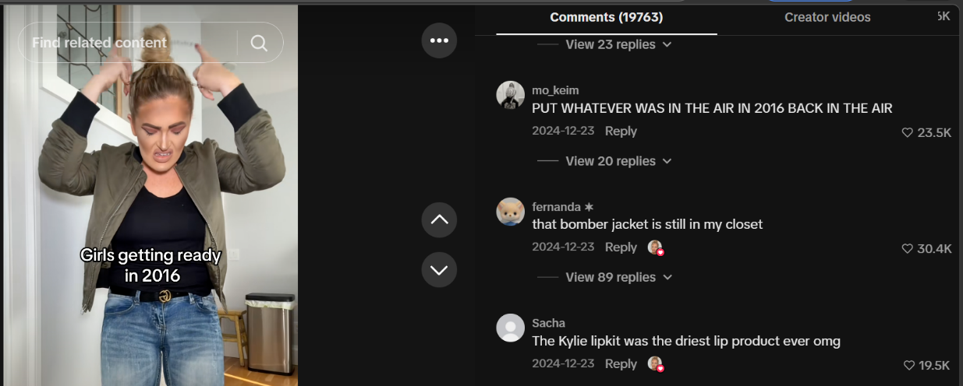

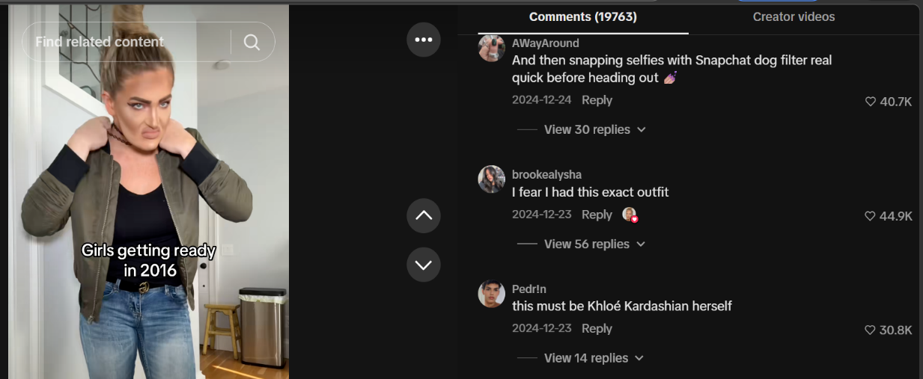

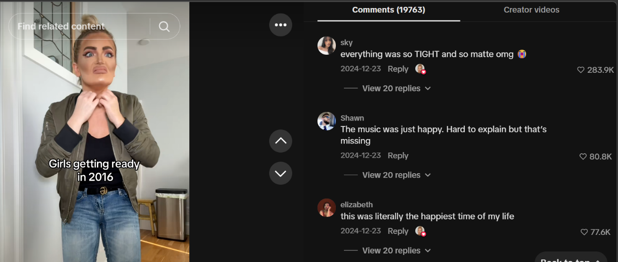

Figs. 1-3. Users comment responding to a TikTok posted by isabelblanc, highlighting recurring phrases and shared interpretations of 2016 fashion.
Figures 1-3 show a TikTok made by a very popular meme maker, Isabel Blanc, who has 4.4 million followers and 342.4 million total account likes. The video itself accumulated over 23 million views and 2.3 million likes. What stands out most is the comment section, which becomes a site of collective validation rather than simple reaction. Users repeatedly reference shared material details such as similar jackets, footwear and makeup styles to confirm recognition and position themselves within the same cultural moment represented in the video.
This alignment produces a sense of communal identification. Agreement is not centered on evaluating accuracy but on signaling participation in a shared visual memory. Alongside these acknowledgments, emotionally charged responses such as “this was literally the happiest time of my life” and “PUT WHATEVER WAS IN THE AIR IN 2016 BACK IN THE AIR” further amplify attachment. These comments frame the content as more than recognizable imagery. They position it as symbolically linked to a desired return to that period.

- Dancing Lena and Lisa
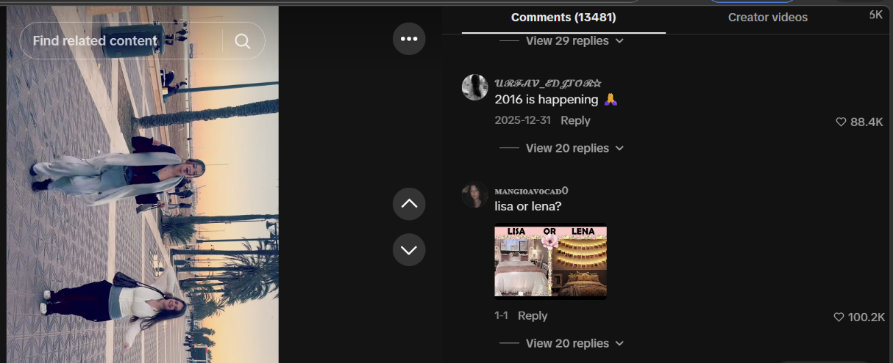

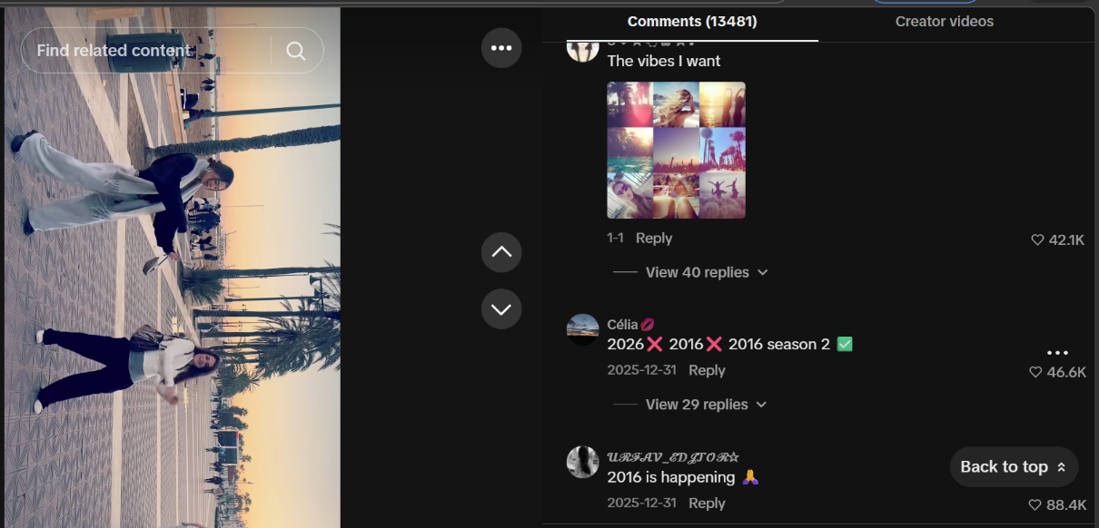

Figs. 3-4. Two sisters, Alessia and Maxi, are using a popular song from 2016 called Lean On, by artists DJ Snake, Major Lazer and MØ in a setting with the lighting and palm trees, most aesthetically associated to 2016.
This TikTok has 16.7 million views and 3.2 million likes. The comments show other images that, like the video, match a color scheme and setting that was most popularized in 2016. The warm tones and beachside setting matched with the song choice sparked this video’s popularity. The mention of “Lisa or Lena” in the comments has nothing to do with the sisters’ names, but instead with another video trend of 2016. This was a version of “this or that” in which different images would show in a video and depending on your preferences, you were assigned the persona of Lisa or Lena. This of course, matched perfectly with the people in the video being two sisters and caused the mention of yet another video trend.
People acknowledging that this was not 2016 “again” but instead a “season 2” of 2016, shows an acknowledgment of a different time, yet also a continuation or reiteration of it. Additionally, it is important to note that many of these comments were made December 31, 2025. There is not a bigger day of expectation for us as a culture than the end of a year and the start of a new one. Having sights set on bringing back what once was, and how many people agree with this sentiment continues to prove collective memory theory by demonstrating how shared interpretations gain momentum through synchronized moments of attention. In this case, the timing of engagement strengthens the alignment of responses, allowing individual expressions to turn into a recognizable collective pattern.
Besides the pushing of algorithms, users who bring up something that was popular in the past will automatically be shown support or be agreed with because it’s more about someone remembering something of your time and not necessarily how they remember it. That is one way Gen Z often finds a way to create community even with the smallest similarities. This reinforces the fact that we are not truly interested in accuracy, but instead the banter of relatability.

- Banter and Trend Identification
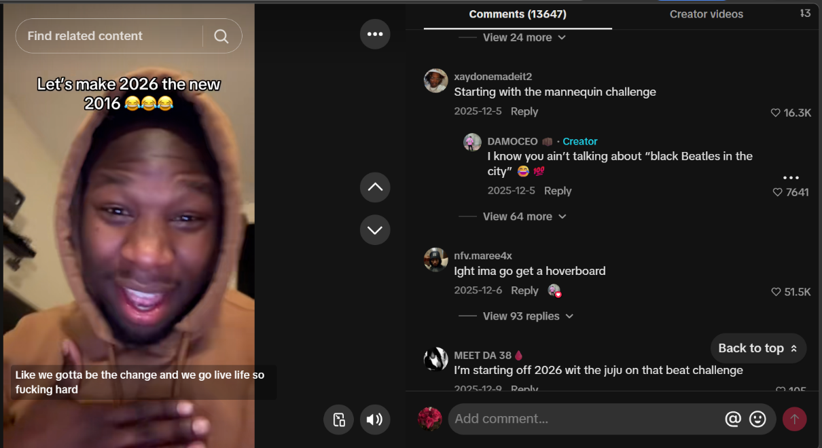

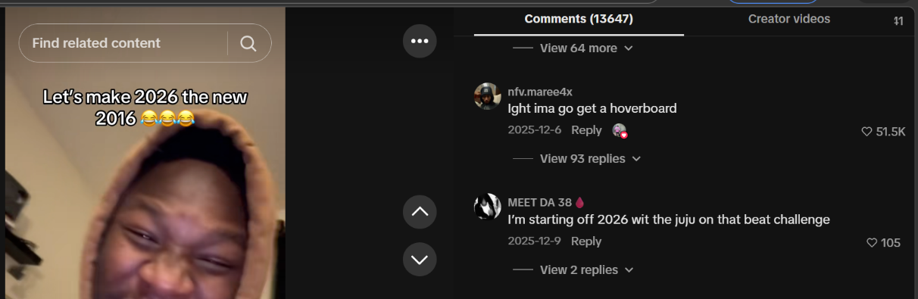
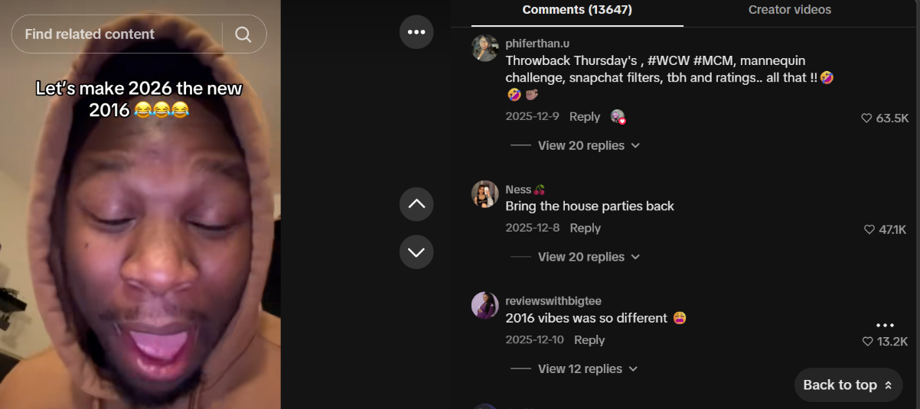

Figs. 5-7. TikTok user, Damoceo, starts a conversation to get everyone onboard with uploading content similar to what was being done in 2016.
Figures 5-7 show a TikTok with 3.3 million views and over 800,000 likes that tries to initiate conversation on or “plan” how the audience should act on social media in the coming year. This video was posted on December 5, 2025 telling people they have some time left to start planning how they will bring back 2016 to social media. The comments immediately identified social media challenges of the time, such as “Throwback Thursdays,” which assigned Thursday as the day everyone would post an old photo. Also,“#WCW,” or, Women Crush Wednesday, where people would post the girl they had a crush on, were too scared to ask out, or already in a relationship with. “#MCM,” Man Crush Mondays, the same as #WCW, the Mannequin Challenge, where everyone froze in the camera frame until failure. Snapchat filters, specifically the dog face filter and the flower crown, as filters on the Snapchat camera were a new addition at the time. Lastly, TBH (to be honest) and ratings which were moments of online “transparency” where people could express their hot takes and unpopular opinions without being judged. House parties and dance challenges are also very popular comments on this video.
What truly ignited the popularity of this video was these exact comments and hashtags placed on the video under a week of its posting. The user who made the video is not even a verified content creator, most of his videos only have 300 likes. So, why was this one so viral? Using his page to upload a video and invite the start of a conversation, provided a platform for a collection or gathering of memories.
In this case, users are not just remembering 2016 independently but actively building a shared version of it through comments and hashtags. The repetition of specific trends like “#WCW,” Snapchat filters, and the Mannequin Challenge stabilizes these elements as defining features of the year, even though they only represent part of the experience. This also aligns with the idea that digital platforms function as spaces where memory is continuously reconstructed, as users contribute, reinforce, and circulate the same references. Rather than preserving the past, the comment section becomes a site where 2016 is collectively reassembled, showing how shared meaning is produced through visibility, repetition and interaction.
Analysis
Across these examples, what stands out is not just that 2016 is being remembered, but how consistently it is being framed in the same way. Specific details, like fashion choices, songs and social media trends, are repeated across posts and comments until they begin to define the year 2016 itself, and in turn, what they want 2026 to look like. This reflects Meyers’ argument that collective memory forms through repetition and shared discourse, where certain interpretations become dominant not because they are complete, but because they are widely circulated (Meyers 318). In this case, 2016 becomes reduced to a set of recognizable and emotionally charged fragments that are easy to repeat and engage with.
At the same time, the emphasis on phrases like “happiest time” or “take me back” suggests that this reconstruction is not neutral. It is shaped by nostalgia, which selectively highlights positive experiences while ignoring complexity. As Niemeyer suggests, nostalgia does not recover the past as it was, but reshapes it into something more emotionally meaningful (Niemeyer 1221). The version of 2016 that emerges across these posts is therefore less about accuracy and more about feeling. This helps explain why even users who may not have fully experienced 2016 still participate in the trend. What matters is not personal memory, but the ability to recognize and contribute to a shared narrative.
This pattern becomes even more significant when considered in a post-pandemic context. Research suggests that Gen Z has experienced shifts in emotional well-being and how happiness is understood following the pandemic (Wang et al. 4). Within this context, the reconstruction of 2016 can be seen as a way of creating a sense of stability and connection through shared cultural references. Rather than looking forward, users turn to a familiar and collectively agreed-upon past. In doing so, they are not just remembering 2016 but using it as a tool to navigate the present. Collective memory, in this sense, becomes less about preserving what happened and more about producing a version of the past that feels useful now.
Gen Z associates 2016 with a coming-of-age time in their lives, through their memories of adolescence and a pre-pandemic utopic idea of the world. The responses to and perceptions of life changes caused by the pandemic may be different across generations (Wang et al. 3), and for Gen Z, trying to bring back a memory that may be inaccurate, but containing a warm feeling may be a way to cope with a difficult start to adulthood. Memories of the pandemic and the way our world has continued to shift into difficulty since then, reign true for most people no matter your age or political inclinations. For a generation that had to “grow up” online, this is all they have to show for it.
At the same time, people do not use social media in the same way throughout their lives. Early patterns of participation often shift into more selective and reflective use, but traces of those earlier habits still shape how cultural references are understood and shared. This matters especially because Gen Z is now the largest active group on many platforms, meaning the ways they first learned to engage online are increasingly shaping how communication looks and feels across social media. Rather than preserving the past, the comment section becomes a space where 2016 is collectively reassembled, showing how shared meaning is formed through what is seen, repeated, and engaged with.

Conclusion
These findings suggest a shift in what collective memory does in digital spaces. Rather than attempting to help people remember, it begins to function as a way of organizing emotion and identity in the present. The revival of 2016 is not just about nostalgia, but about creating a shared point of reference in a moment that feels uncertain. When users ask, “Will this be the new 2016?” they are not only looking backward, but also trying to define what the present should feel like moving forward.
At the same time, the resurgence of 2016 should be understood as a case study rather than an isolated phenomenon. The same patterns, repetition, selective framing and shared participation, can be seen across other revived trends, aesthetics and cultural moments online. This suggests that what is happening with 2016 is part of a broader process, where digital platforms make it easier to turn any recent past into something collectively recognizable and meaningful. In this way, collective memory in digital environments becomes less tied to specific events and more connected to an ongoing need for shared understanding.
As platforms continue to prioritize visibility and engagement, the past becomes a flexible resource that can be reshaped to meet present needs. Memory is no longer just something we inherit, but something we actively use, not only to remember where we have been, but to make sense of where we are and what comes next.
Future research could further examine how these dynamics vary across different types of digital platforms. Short-form video environments may accelerate the transformation of recent cultural moments into recognizable symbols, while other platforms may preserve or organize content in ways that produce different relationships to digital memory. Comparing these environments could help clarify how platform design itself shapes what becomes culturally memorable and what fades from visibility.
Additional study is also needed on how participation in these memory-based trends shifts across different user groups over time. As users move through different life stages, their relationship to earlier digital experiences may change in ways that influence how they engage with revived cultural content. Understanding whether these patterns remain consistent, weaken or evolve could offer insight into how digital memory functions across longer timelines.
Finally, this topic would benefit from research that integrates computational methods with a closer qualitative analysis. Tracking patterns of repetition, engagement and content resurfacing at scale could help identify how certain cultural references gain momentum across networks, while closer interpretive work could further explain how users attach meaning to them. Together, these approaches could provide a more complete understanding of how collective memory is actively produced within digital environments.

Works Cited
Adriaansen, Robbert-Jan, and Rik Smit. “Collective Memory and Social Media.” Current
Opinion in Psychology, vol. 65, Oct. 2025, pp. 1–77.
Couldry, Nick, and Andreas Hepp. The Mediated Construction of Reality. Polity Press, 2017,
pp. 120–150
disappearfromtheworld. “Thoughts on 2016 Nostalgia.” TikTok, 5 Dec. 2025.
Hoskins, Andrew. “Digital Network Memory.” The Routledge Handbook of Memory and
Communication, edited by Anna Reading and Tamar Katriel, Routledge, 2015,
pp. 89–104.
Hoskins, Andrew. “Media, Memory, Metaphor: Remembering and the Connective Turn.”
Parallax, vol. 17, no. 4, 2011, pp. 19–31.
isabelclanc. “Meme Video Referencing 2016 Fashion.” TikTok, 23 Dec. 2025.
Keightley, Emily, and Michael Pickering. “The Mnemonic Imagination: Remembering as
Creative Practice.” Media, Culture & Society, vol. 34, no. 5, 2012, pp. 576–593.
Meyers, Oren. “Collective Memory.” The International Encyclopedia of Communication Theory
and Philosophy, edited by Klaus Bruhn Jensen and Robert T. Craig, Wiley-Blackwell,
2016, pp. 318–323.
Niemeyer, Katharina. “Media and Nostalgia: Yearning for the Past, Present and Future.” Media,
Culture & Society, vol. 36, no. 8, 2014, pp. 1219–1235.
Nora, Pierre. “Between Memory and History: Les Lieux de Mémoire.” Representations, no. 26,
1989, pp. 7–24.
Wang, Chen, et al. “Changes of Well-Being over the Pandemic: A Survey across Generational
Cohorts.” BMC Public Health, vol. 25, 2025, article 102077.
yourfavsiiblings. “Video Referencing 2016 Dance/Audio Trend.” TikTok, 31 Dec. 2025.

