Benjamin Allee
COM 415

In His Image: The Development of an Ideographic Negative in Trump’s Flickr Photography

Abstract
Beginning after his inauguration in 2017, Donald Trump’s team of photographers regularly posted photos of the president on the official White House Flickr account. When considered as pieces of presidential rhetoric, the media on this account bear unique rhetorical effects due to their ability to present a record of the president’s term and create associations or dissociations between the visual form of the president and other visual signs. As a result, this study finds that the dissociation of the president’s form in relation to other ideological signifiers over time ideologically complicates his appearance to the extent that it becomes a visual ideograph. Finally, this research concludes by discussing the implications of the potential usage of this ideograph by a public audience before identifying areas for further research.

End of abstract

In 2009, the Obama administration opened an account on Flickr, a popular photo-sharing website for both amateur and professional photographers; White House photographer Pete Souza headed the effort, posting photos that captured the next eight years of Obama’s presidency to critical acclaim (Groner, 2012). After Donald Trump took office in 2017, the official White House account was emptied and slowly refilled with the imagery of a new leader, taken by a new team of media professionals led by photographer Shealah Craighead (O’Kane, 2017). According to the upload dates visible on the account, the resulting images were posted on a regular basis, documenting almost every day of the president’s term; at the time of writing, the official White House Flickr account reports over 14,000 photos, over 118,000 followers, and over 95 million total views (The White House, 2020).
When compared to the Trump administration’s current 100+ million combined followers across Instagram, Facebook, and Twitter, the Flickr account is clearly far from the administration’s primary form of visual communication with the public, yet the photography included on this platform still serves as a place for anyone to freely find and use official photography of the president himself. This level of access to official White House media makes the Flickr account, therefore, a way for the president to promote a visual tone to his constituents (Chun, 2018).
The photography posted to this account since Trump’s arrival has received its share of derision from cultural critics, particularly for lacking a level of access and aesthetic quality found in imagery from the preceding administration (Shaw, 2017). Where Souza’s work is seen as providing unprecedented perspective on Obama’s time in office, critics claim Craighead and her team have been farther removed from their subject matter, limited to shots that emphasize the spectacle and staging of the president’s work rather than a sense of intimacy and relatability (Chun, 2018). These criticisms characterise Trump’s Flickr account as one that omits visual messaging which was characteristic of the previous administration. Beyond that level of omission, however, this paper will present more intentional ideological omissions as part of Trump’s visual rhetorical strategy, and will evaluate the extent to which the implications of these communicative absences go beyond considerations of mere aesthetic and perceived accessibility.
Since Trump’s official photography serves to promote a visual identity for the president, specific rhetorical omissions in this media may notably complicate and refine Trump’s image in particular through visual communication. With this complication in mind, we must ask ourselves how Trump’s visual silences act as rhetorical and political devices to shape the president’s definition as it exists at the intersection between ideology and visual representation. I suggest that Trump’s Flickr photography, through the use of strategic ideological dissociation, may continuously complicate the ideological freight of his visual form in a way that delineates and distributes the image of <Trump>, an ideograph created and maintained both by what is shown, and what is not.

Literature Review
In 1980, Michael McGee first introduced his theory of a communicative concept at the intersection between common language terms and complex ideologies. McGee defined these devices, which he labelled ideographs, as culturally-specific terms bearing complex ideological weight and justifying social paradigms for both the powerful and their audiences. He further established that these terms can be created, refined, and utilized according to two distinct timescales: they function diachronically inasmuch as they are developed slowly over time, while they function synchronically to the extent that they are structured in tension with other contemporary ideographs (McGee, 1980).
Since then, scholars have identified ideographs in various areas of contemporary discourse, including in visual rhetoric. In 1997, Edwards and Winkler first postulated the existence of the visual ideograph, a communicative form that represents complex ideology to such an extent that it transcends whatever iconic or linguistic associations it may have had traditionally (Edwards & Winkler, 1997). These visual ideographs, along with their verbal counterparts, are commonly used in public discourse as references to specific cultural ideals (McGee, 1980). Ideographs in general are also intentionally invoked and characterized by those in power to reinforce multifaceted ideological priorities among the public, but even those in prominent social positions are not above an ideograph’s influence and cultural meaning (McGee, 1980). This means that the powerful cannot objectively define these terms in full, though they can still influence their definitions through their synchronic and diachronic usage (Condit & Lucaites, 1990).
Edwards and Winkler pointed out four specific qualifications that distinguish visual ideographs from other visual terminology. Drawing fundamentally from McGee’s original definition, they established that visual ideographs must (1) be an ordinary term in political discourse; (2) be an abstraction representing collective commitment; (3) warrant power and guide behavior; (4) be culture-bound. In short, ideographs must be inclusive enough to be ordinary, but exclusive enough that they apply to a particular culture when they are used in an ideological context; when they are employed, they must represent a collective ideal in simple terms and reinforce certain power structures based upon those ideals (Edwards & Winkler, 1997)
While these terms can manifest both as verbal terminology and representative form, ideographs can also be attached to specific represented entities, even individuals. In these cases, they serve at the surface level as a representation of a person in particular, while also representing specific, less-apparent ideologies surrounding that individual’s character and political relevance (Stassel & Bates, 2020). When ideographs of any kind are invoked, however, study has revealed they can grant their user a unique capacity to transcend specific environments, groups, and individual references. This is because the use of ideographs in specific rhetorical environments can influence the terms’ exclusionary capacities; in reshaping how an ideograph is accepted by a group in this way, one can then use that term to transcend an otherwise restrictive rhetorical context (Towner, 2010).
Not unlike how ideographs allow speakers to transcend a situation, silence as a rhetorical device allows its users similar transcendent communicative power. When speakers use silence as a communicative tool, they can reshape ideological definitions and leverage community ideals to avoid explicitly explaining gaps in information; in effect, silence allows a speaker to remove herself from rhetorical conflict (Connelly, 2012). However, as theorized by Barry Brummett, omitting information in political contexts often comes at a certain cost; by neglecting to comment on or record specific ideas that may be expected by the public, a rhetor relinquishes a certain amount of control over that discourse to the audience, allowing the audience to create interpretations of that figure’s relation to the topic unmentioned (1980). As a strategic tool, then, Brummett finds that silence poses a level of communicative risk (1980).
Broadly, maintaining any sense of discursive control in politics since the latter half of the 20th century has increasingly depended on commanding visual media, as opposed to verbal communication (Grabe & Bucy, 2009). Photography, in particular, has a unique political role due to its abundance and accessibility, rendering it an invaluable medium as a tool for shaping the political identity of communicative society (Hariman & Lucaites, 2016). In his review of existing communication scholarship on visual political imagery, Edward Schill presented a theory of the key uses for imagery in politics (2012). As he explained, an image used for political ends could perform any of ten particular functions: (1) serve as a loose argument; (2) set a media agenda; (3) dramatize policy through narrative; (4) aid in emotional appeals; (5) build a candidate’s image; (6) create identification; (7) provide documentation and argumentative evidence; (8) connect to societal symbols; (9) transport the audience to virtual worlds; (10) add ambiguity to claims (Schill, 2012). While Schill evaluated political image functionality according to this model, political visual rhetoric has certainly been evaluated through other theoretical frameworks.
Russell Chun’s 2018 analysis of Trump’s Flickr photography, for instance, used a dramatistic approach to compare images from the first 100 days of Trump’s presidency to those from Barack Obama’s, identifying the nuances of Trump’s narrative positioning and overall visual symbolism. The study found that Trump’s Flickr photography consistently emphasized power, popularity, and individualism as visual topos, while often neglecting to provide complexity of composition or overall aesthetic (Chun, 2018). Although not drawing from this particular study, cultural critics evaluating Trump’s visual strategies have argued that his emphasis on these themes serves as a prime example of his authoritarian tendencies in office (Morris, 2020). Renowned filmmaker Erroll Morris, for instance, performed a visual analysis in The Atlantic magazine on images posted to the account that had been taken on June 1st, 2020. On that day, protestors in LaFayette Square in Washington D.C. were aggressively cleared out of the area, ostensibly to make way for a photoshoot for the president at the nearby St. John’s Parish Church; the tactics used to clear the posters, as well as the images from the photo shoot, received ethical and aesthetic criticisms from a gamut of popular resources (Morris, 2020; Bennett et al., 2020; Baker et al., 2020).
Beyond the purely visual, Trump’s rhetoric writ large has been criticized for relying on a language of victimhood, rage, and inability; in doing so, it synthesizes an ideology of political strength, revenge, and involuntary impotence as a response to oppositional political systems (Kelly, 2020). As Casey Kelly found, however, this ideology of strength, revenge, and impotence relies heavily on the rhetorical imagination of an ideal: in his rhetoric, Trump communicates an idealized vision of both himself as a figurehead and America as a nation, which is then used to reframe political principles of vengeance and victimhood as civic virtues (2020). Research on presidential rhetorical tradition from scholars Karlyn Kohrs Campbell and Kathleen Hall Jamieson delineated the many genres by which presidential rhetoric may communicate these sorts of ideals (2008). In their work, Campbell and Jamieson established broader functions and forms of presidential rhetoric as they have been observed throughout presidential history; they noted genres such as the State of the Union address, a rhetorical tradition in which the president’s “report[ing] on events can become a vision of the future,” which then frames legislative pursuits from Congress, provides public meditation on America’s past, and determines the assessment of current crises in the country (2008). Trends in past presidencies have seen these speeches become more informal—transitioning from written releases to speeches—in part to give the speeches an air of cooperation between rhetor and audience (Campbell & Jamieson, 2008). Vanessa Beasley’s research on presidential rhetoric further established how speeches such as those described by Campbell and Jamieson serve to create a unified vision of the country; Beasley found that ideographs lend themselves well toward these rhetorical ends due to their capacity to delineate, enforce, and reshape community groups (Beasley, 2001).

Methods
Over the course of this research, I will conduct an ideographic textual analysis on a selection of photographs from the White House’s Flickr account, each from the year 2020, in order to dissect an interplay between rhetorical omission and ideological representation in Trump’s visual media. This research seeks to show if, and how, Trump’s visual rhetoric employs silence over time in order to ideologically complicate and refine his image as president, utilizing theories of political imagery, presidential rhetoric, and visual ideography as frameworks.
To best isolate the ideological messages conveyed in the images on this account, this essay will first apply previous research and common criticism of Trump’s early Flickr photography to images documenting 2020; this will determine whether trends found in Trump’s rhetoric writ large by Kelly, as well as the trends identified in his first 100 days of Flickr photography by Chun, remain present in the account’s material from 2020 as well (2020; 2020). While selecting the exact imagery in question is unavoidably a subjective process, the photographs used in this research will be emblematic of those ideas which were identified by previous scholarship, if those ideas remain visible. After identifying how Trump’s rhetoric is broadly available in this photography, I will isolate how this rhetoric conforms more specifically to the communication of a specific ideology, which may be associated with particular visual terms in the photography over time. Then, by applying the requirements of an visual ideograph as defined by McGee in 1980 and Edwards and Winkler in 1999, I will distinguish which visual terms in the images may qualify as ideographic rather than merely rhetorical. Understanding the potential formation of an ideograph in context requires, too, an understanding of the rhetorical capacity of the Flickr account as a device of presidential rhetoric; therefore, I will also analyze the unique functions of this account’s imagery as political imagery, using the framework provided by Schill, and presidential imagery, which may perform functions similar to those suggested by Campbell and Jamieson (2012; 2008). To understand by what manner certain terms—namely the representative form of the president—are formed ideographically, I will then analyze how the image of the president is associated and dissociated with ideological signs according to a particular time scale and by particular rhetors. This will be made possible by comparing the ideological significations and disseminations of the president’s form with those of a comparable visual ideograph, that of the <angry white man>, as identified by Stassen and Bates (2020).
Throughout the research process, my work will draw on the foundational definition of the ideograph as written by Michael McGee, who first established how these terms are formed and communicated, as well as the work of Edwards and Winkler, who expanded McGee’s definition to include visual terminology (1980; 1999). Lastly, this research will conclude with notes on how Trump’s image as a political communicative tool may be distributed and redefined by specific audiences, along with notes on possibilities for future research.

Analysis
Scrolling through the pages of Trump’s White House Flickr account, one may arrive at a general sense of consistency founded upon spectacle, authority, and intentional posture; Chun first wrote on this visual strategy, which he concluded offered a “preponderance of posed, photo-op images preclud[ing] opportunities for more compositionally original images” (2018). Beyond aesthetic criticisms, he found that the visual strategy of the account in its earliest months emphasized the posed, the authoritative, the positive, and the powerful (2018). Although Chun’s analysis was isolated to the first 100 days of imagery on the account, these themes remain visible in Trump’s Flickr photography during the year 2020. At the beginning of the year, images of the president and his cohort on a trip to India consistently associate him with spectacular spaces of great scale, renown, and history, as seen in Figure 2, often in an ostensibly authoritative and choreographed posture (The White House, 2020). Throughout the remainder of the year, the account’s content continued to reinforce Chun’s findings in which the imagery “highlight[ed] the individuality and singularity of the President...the scrum of the media or the adoration of public crowds…[and] public pronouncements of his power” (2018).
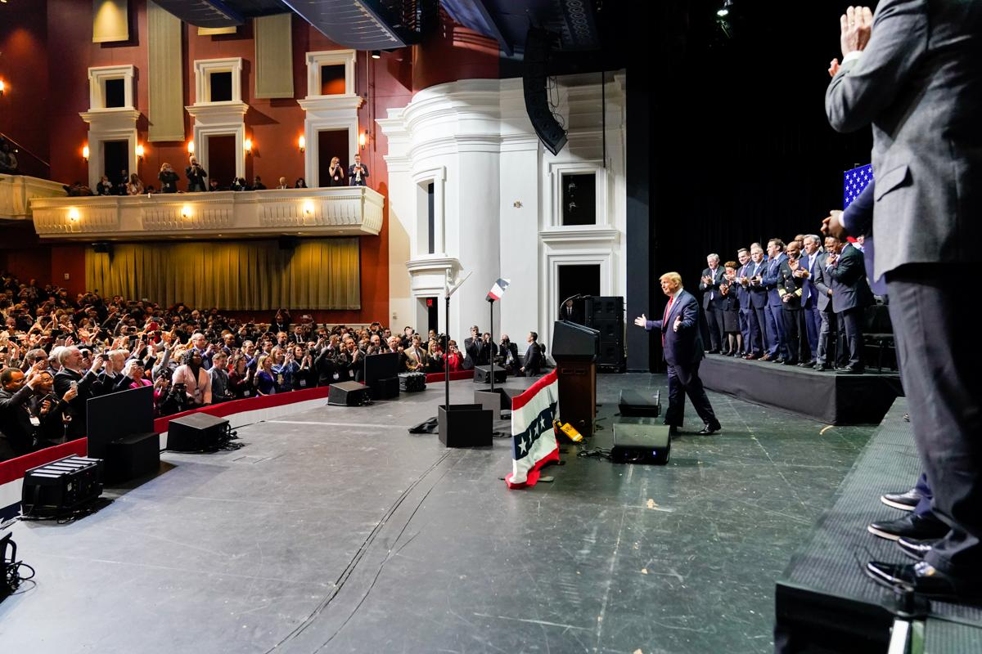 | 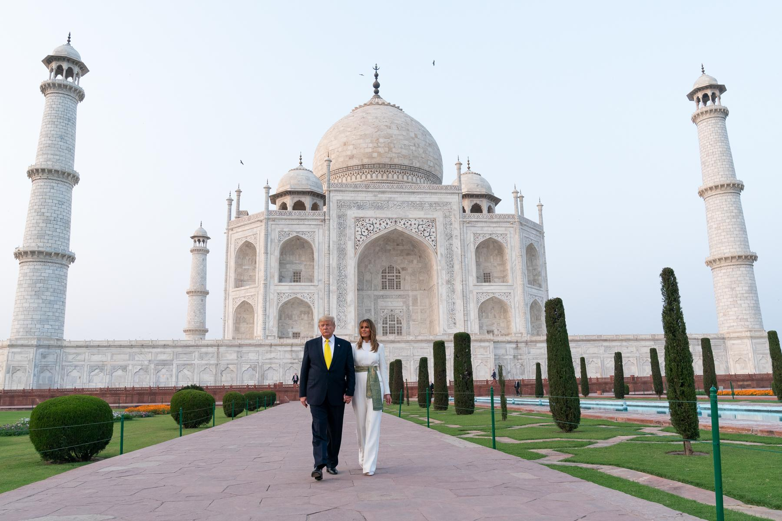
Fig. 1. Craighead, Shealah. “President Trump Delivers Remarks at the North Carolina Opportunity Now  Summit.” Flickr, SmugMug Inc., 7 Feb. 2020, https://www.flickr.com/photos/  whitehouse/49503339221/. | Fig. 2. Hanks, Andrea. “President Trump and the First Lady in India.” Flickr, SmugMug Inc., 24 Feb.  2020, https://www.flickr.com/photos/whitehouse/49583714032/.
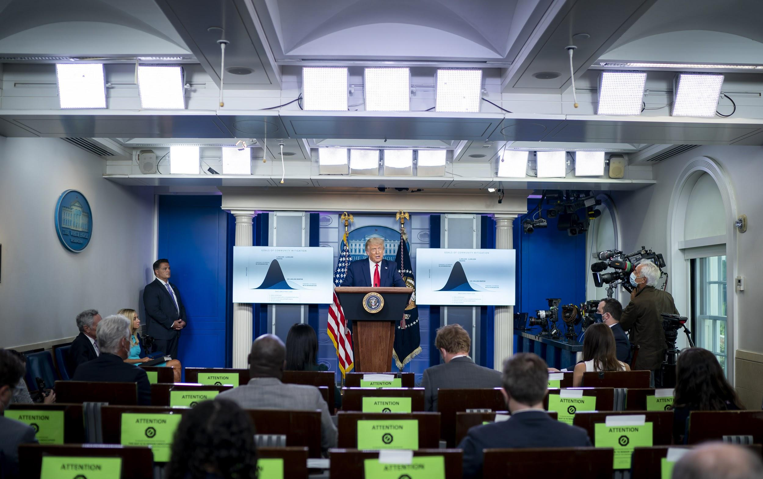 | 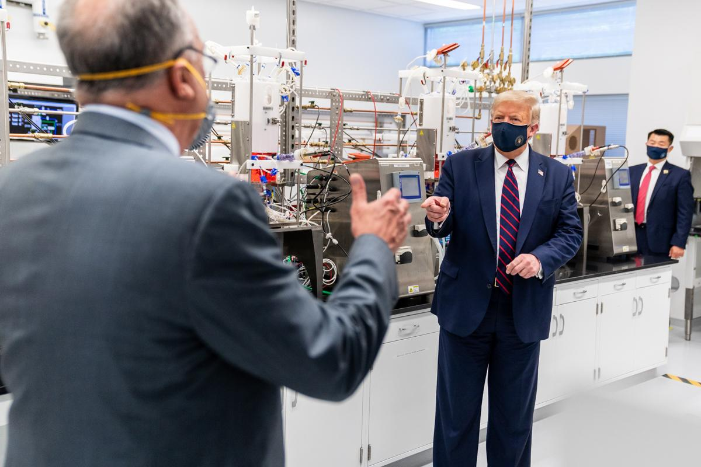
Fig. 3. Dufour, Tia. “White House Press Briefing.” Flickr, SmugMug Inc., 16 Sept. 2020, https://www.flickr.com/photos/  whitehouse/50352466851/. | Fig. 4. Craighead, Shealah. “President Trump at the Bioprocess Innovation Center at Fujifilm Diosynth  Biotechnologies.” Flickr, SmugMug Inc., 27 July 2020, www.flickr.com/photos/  whitehouse/50162729881/.
Despite the relative uniformity and temporal consistency of these themes and compositions, it would be false to claim that President Trump’s Flickr photography does not rhetorically evolve in relation to current events. Take, for instance, visual references to the COVID-19 pandemic on the account. There are dozens of photographs of the president at COVID press briefings, as exemplified in Figure 3, which serve as one of the account’s most common visual references to the pandemic (The White House, 2020). Outside of these shots in press briefing rooms, images with a notable relation to the sickness and its effects on the American public often present Trump on panels discussing relief efforts with political figures, in one-on-one conversations with governors and other state officials, or on visits to medical companies at work on the virus, as seen in Figure 4 (The White House, 2020). These photographs avoid, however, showcasing the symptoms of the disease, both on the individual and societal scales; this includes during the period in which Trump himself contracted the virus in September. Even when Trump was at Walter Reed Medical Center actively receiving treatment for his symptoms, as pictured in Figure 5, the visual expression of his intense personal authority returned in the Flickr imagery (The White House, 2020). In this instance, the composition isolates his form in a position of confidence, surrounded by a grand conference room and buttressed by the American and presidential flags, his steady expression set directly toward the camera as he leans slightly over the table. Images such as this demonstrate the president as unaffected, if not visually immune, to the effects of the virus.
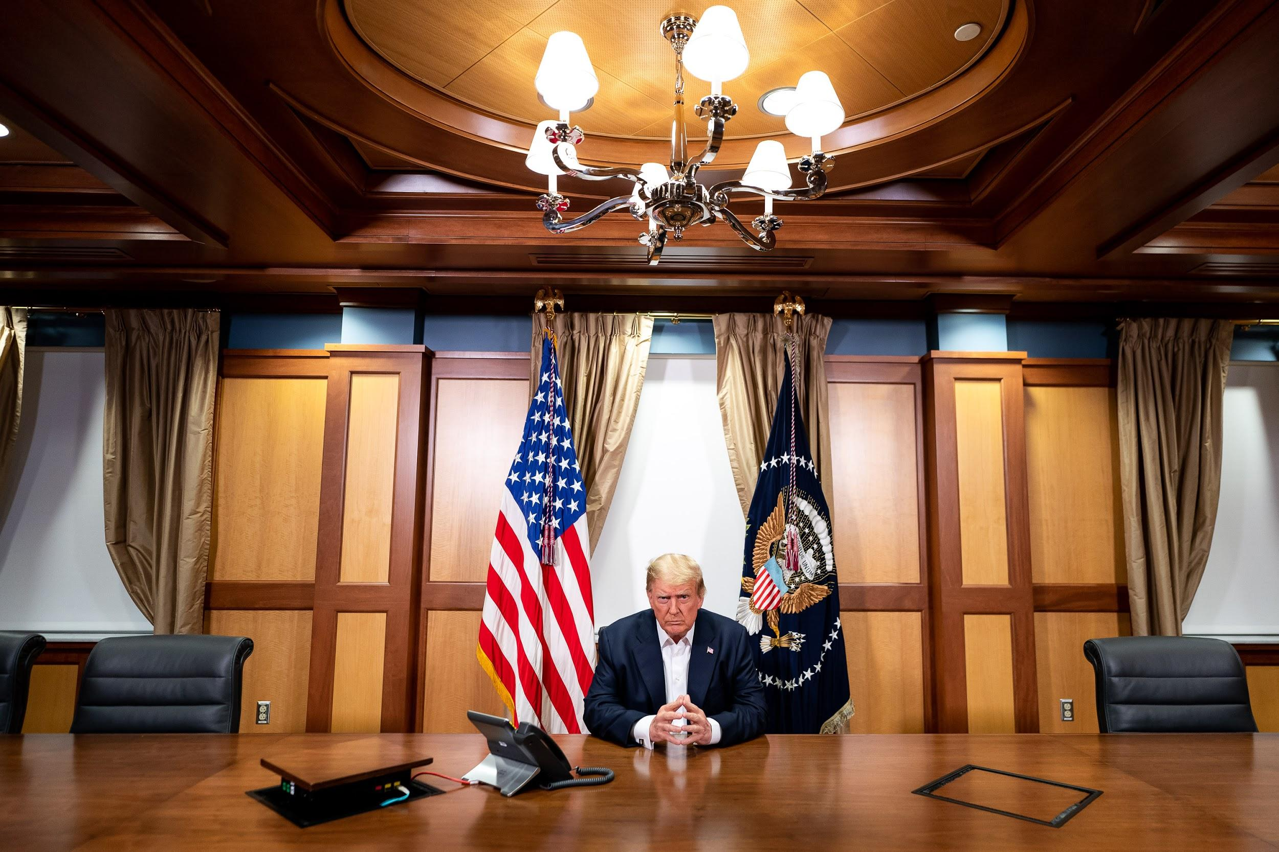
Fig. 5. Dufour, Tia. “President Trump Works at Walter Reed National Military Medical Center.” Flickr,
SmugMug Inc., 4 Oct. 2020, https://www.flickr.com/photos/whitehouse/50423967302/.
Especially as exemplified by Figures 3, 4, and 5, the account’s Flickr photography records the era of a pandemic as a process of consistent, authoritative problem-solving from the executive office: in Figure 3, the situation is visually handled by Trump’s authority in the briefing room, in Figure 4, it is handled by his cooperation with American businesses, and in Figure 5, it is conquered by him personally. What the photography does not present is a record of the disease’s negative impact on the American people, even when that includes the president in particular. Less than a week after his diagnosis, Trump further articulated an optimism for the COVID situation, despite his contraction of the disease, on Twitter:
...Feeling really good! Don’t be afraid of Covid. Don’t let it dominate your life. We have developed, under the Trump Administration, some really great drugs & knowledge. I feel better than I did 20 years ago! (@realDonaldTrump, 2020)
None of this is to suggest that the White House Flickr account has an outlined obligation to record American history to an explicit journalistic or historical standard. Record-keeping is not even necessarily the primary function of political photography; it is, however, a function nonetheless, one made all the more significant when the imagery is not only political, but presidential.
As noted by Schill in 2012, political imagery has the capacity to serve a number of functions. For the purpose of this research, however, the capacities for political photography to 1) create basic arguments through visual association and dissociation, and 2) serve as a historical record of a politician’s acts are of particular interest. This is because to the extent that photography associates terms with each other (relating to the first function) over delineated periods of time (relating to the second function), one may be able to identify the definition and qualification of ideographic messaging in that media. To reduce the White House Flickr account to mere political messaging of the kind studied by Schill, however, would not acknowledge the account’s singular position in politics as a resource of America’s highest office.
In Presidents Creating the Presidency: Deeds Done in Words, Campbell and Jamieson described the broader functions (as they associate with genres) of presidential rhetoric as they have been observed throughout presidential history (2008). Schill echoed their research in his recognition of the history-making function of political imagery, a function which Campbell and Jamieson identified as of particular relevance to presidential ‘State of the Union’ rhetoric, which is most obviously available in the annual State of the Union Address.
For the purpose of this research, one cannot conclude that any given image of the Flickr account may or may not be accurately typified according to Campbell and Jamieson’s State of the Union genre; yet, inasmuch as presidential rhetoric displays the presidency in relation to its current figurehead and the nation that figure leads, this rhetoric may allow the president to fulfill “the role of national historian, giving them the opportunity to reconstruct the past in order to forge the future” (2008). Trump’s rhetoric on Flickr, then, is not limited to Schill’s cataloging of personal political efforts, but also presents an image of America that bears unique chronological relevance because it creates an official, highly-catalogued narrative of the nation’s history in the moment that history is being created. The America in which Trump functions in relation to the various dilemmas of 2020, for instance, is presented according to a Trump-based ideology: as articulated by Kelly, this is an ideology in which Trump as an individual works tirelessly and purely against otherized forces, a vision which depends on the presentation of both a virtuous figurehead and an idealized vision of America (2020). Trump’s work, then, remains prioritized, while events external to—or even inspiring—that work remain unseen.
In Figures 6, 7, and 8, respectively, one sees the Flickr account’s record of Trump at a briefing for the west coast fires of early September, a signing during the COVID-19 pandemic around the time the death toll crossed 200,000 later in September, and at a briefing about the hurricanes and tropical storms that would soon hit American shores in May, causing nearly $40 billion in damage (The White House, 2020; New York Times, 2020; Chappell, 2020; Samenow et al., 2020).
Fig. 6. Craighead, Shealah. “President Trump in California.” Flickr, SmugMug Inc., 14 Sept. 2020, www.flickr.com/photos/whitehouse/50344668423/.
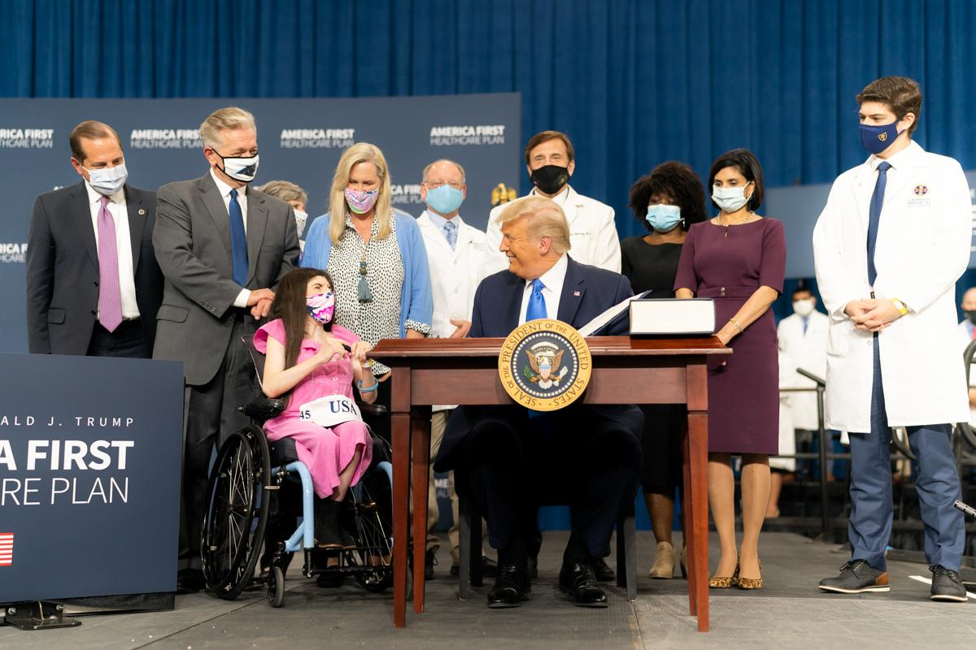
Fig. 7. Craighead, Shealah. “President Trump Delivers Remarks on the America First Healthcare Plan.” Flickr, SmugMug Inc., 24 Sept. 2020, www.flickr.com/photos/whitehouse/50382649527/.
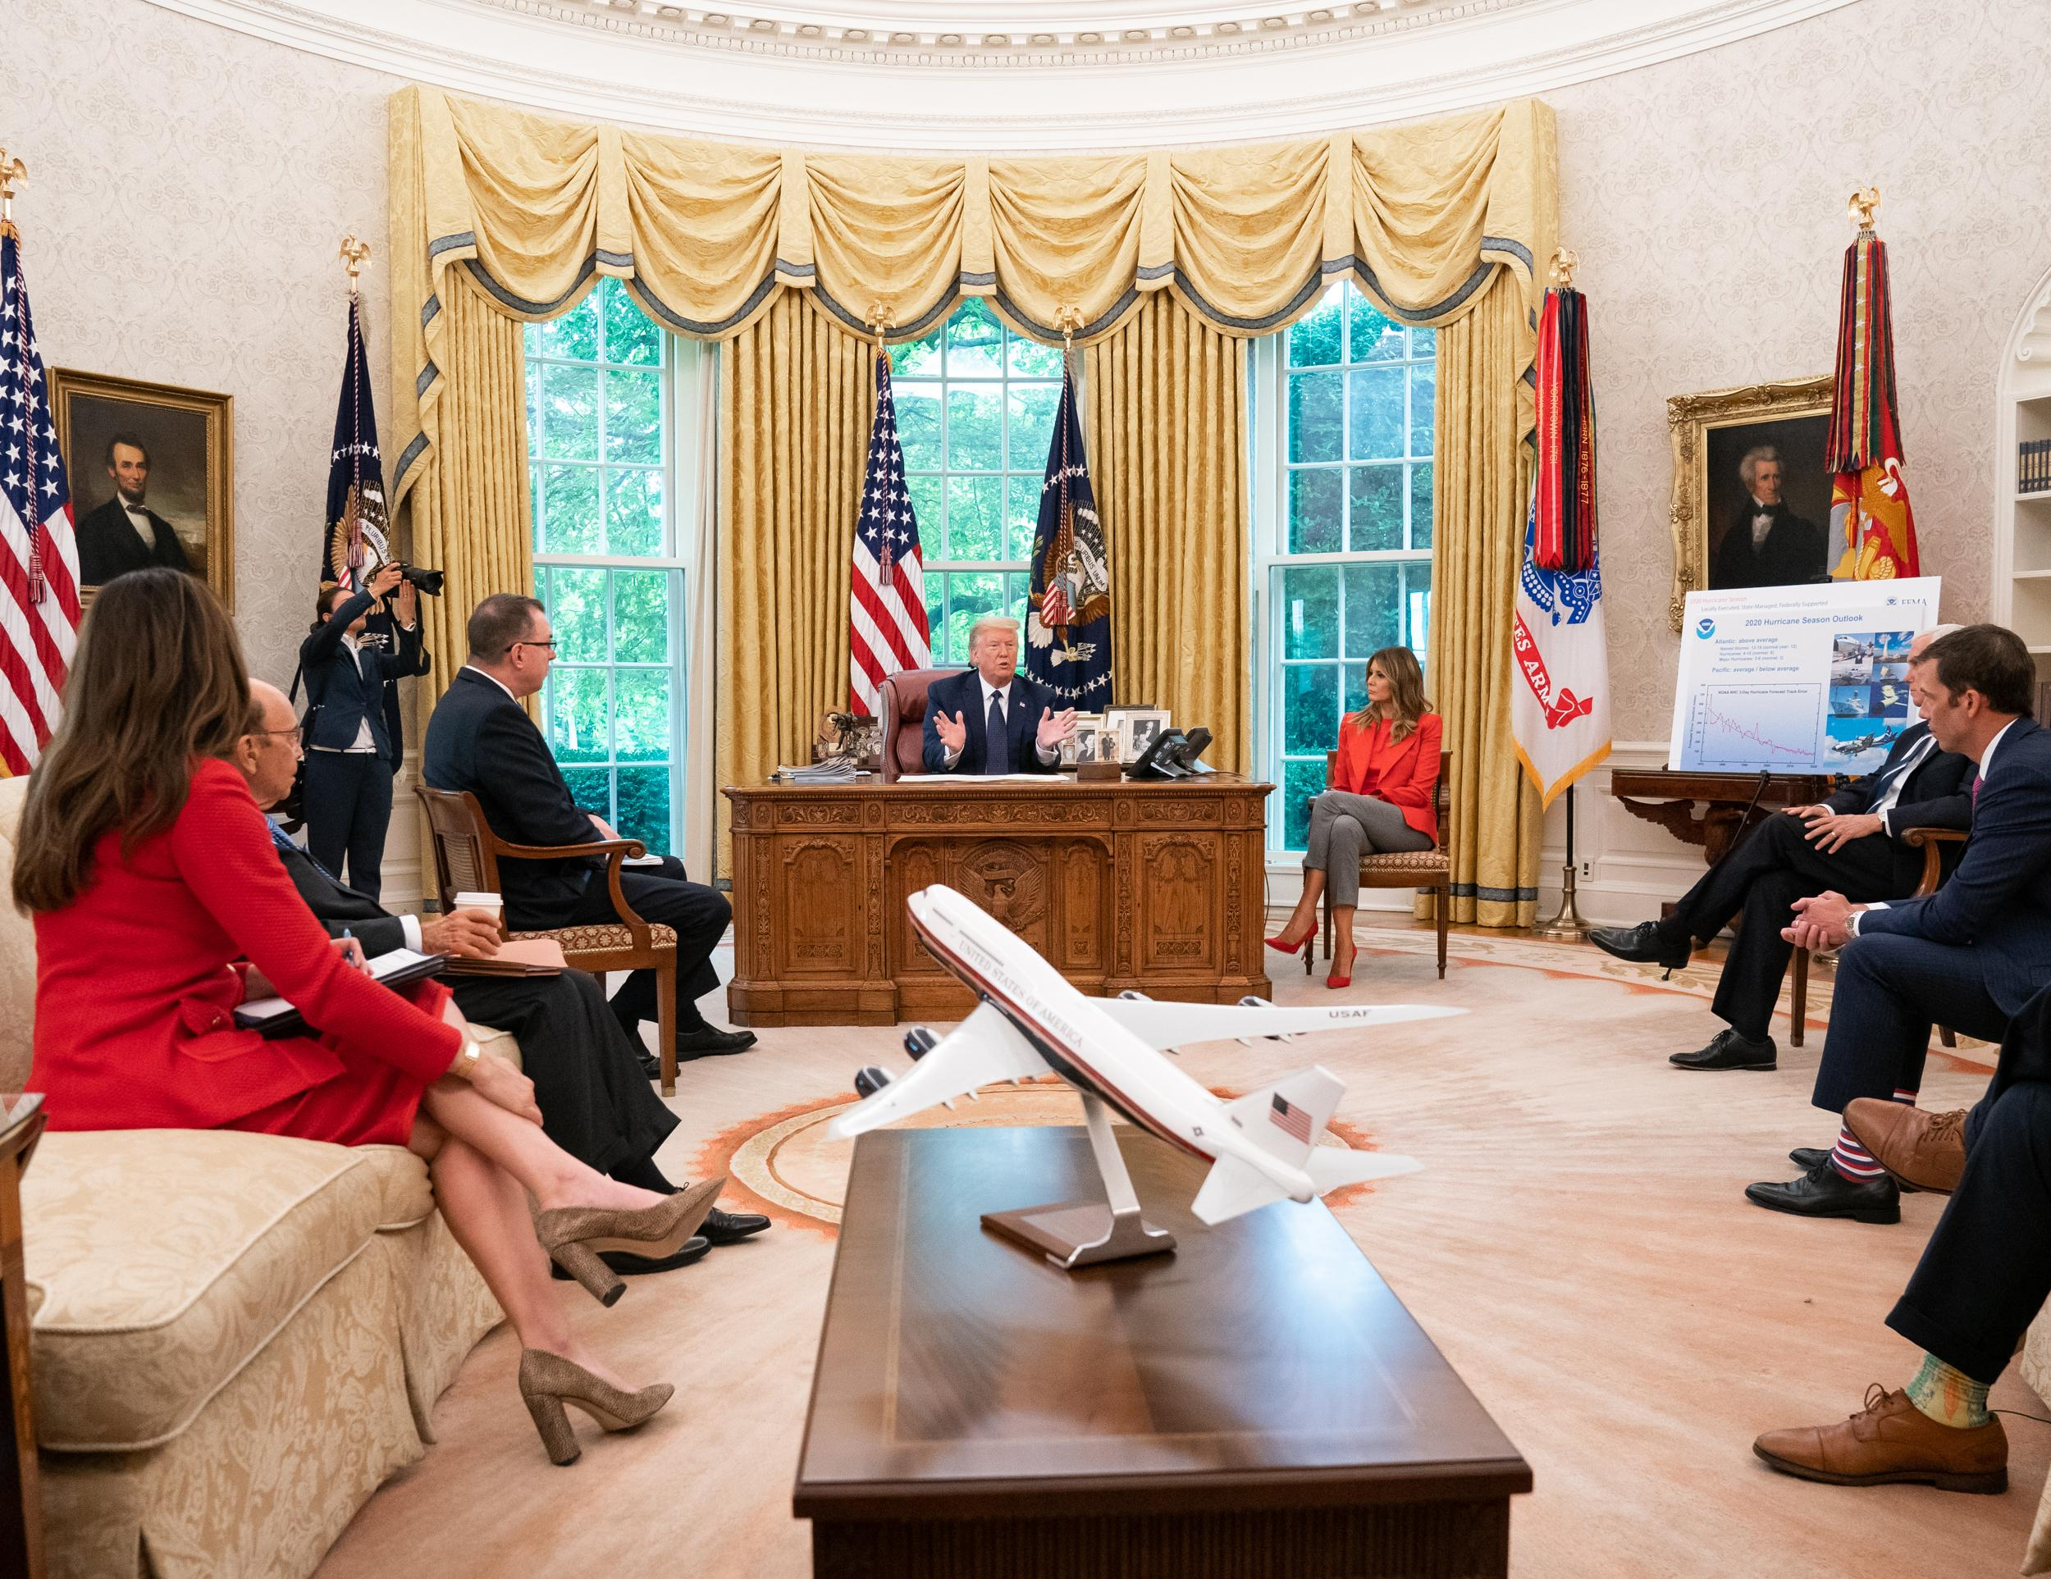
Fig. 8. Craighead, Shealah. “2020 Briefing on the Hurricane Season.” Flickr, SmugMug Inc., 28 May 2020, https://www.flickr.com/photos/whitehouse/49949230611/.

In images taken on the dates surrounding these events, as with a large portion of the imagery on the account, Trump is often prominent in the composition, either listening to a selection of experts or addressing an audience of supporters. In Figure 6, Trump is poised at the head of a table as he receives a briefing on wildfires which were spreading across the west coast U.S. at the time, displacing hundreds of thousands (The White House, 2020; New York Times, 2020). At no point in the account’s photographs from September will one find Trump amid the wreckage caused by the disaster.; instead, Trump is most often pictured as he is in Figure 6, often in stagnant poses with a uniformly-displayed audience or panel of experts (The White House, 2020). In this picture, he is presented just beneath the eye-catching technology being used to combat the issue, a large plane, which acts as a symbol of American industry, strength, and problem-solving, while minimizing the depiction of the symptoms of the problems being solved (The White House, 2020). This strategy is available again in Figure 7; as the death toll of the coronavirus passed 200,000 in late September, Trump is ceremoniously depicted with a group of health professionals, each with an optimistic smile (The White House, 2020). Lastly, in Figure 8, one again sees the clear establishment of President Trump amid an audience, this time a handful of advisors in the Oval Office during a May briefing on the approaching hurricane season (The White House, 2020). There, one can find a model of a plane, further reiterating an association between the president and themes of the grand and manufactured. These images, as perceived through the eyes of the Trump administration, do not present the viewer with an America—nor even an executive—in distress. Instead, viewers find an executive in progress, in celebration, and in confidence, themes made visible when he is surrounded by admirers or the media, enveloped by settings and devices of great scale and innovation, and positioned with optimistic expressions and stable, often-choreographed poses of certitude.
This visual rhetoric aligns with Kelly’s analysis of Trump’s rhetoric of ressentiment; as Kelly writes, Trump utilizes nostalgia and victimization in order to motivate action from his supporters (2020). This victimhood, however, first requires the establishment of an “idealize[d] indeterminate” vision of America, as well as a contemporary image of Trump himself as a “noble sacrifice” under persecution from cultural institutions as he defends that envisioned nation; optimistic photography centered on the president as an individual, then, may contribute to a vision of Trump as martyr, which can then be used to justify this politically frustrated ideology (2020).
In the images observed thus far, ideology has been loosely reflected through specific visual themes; this reflection has not yet been specific enough, however, to constitute the existence of a visual ideograph. Terms may connote ideology, but it is another thing entirely for a visual form to transcend both “univocal denotative reference….[and] particular groupings of symbolic or rhetorical contexts” (Edwards and Winkler, 1997). Some representative forms throughout the account’s photography correlate more notably to ideographic terms: as one will commonly find in the account, machinery such as planes, cars, and space shuttles, as seen in Figures 9 and 10, may illicit ideas of <industry>, <progress>, and <ingenuity> that constitute the America Trump hopes to save from injury.
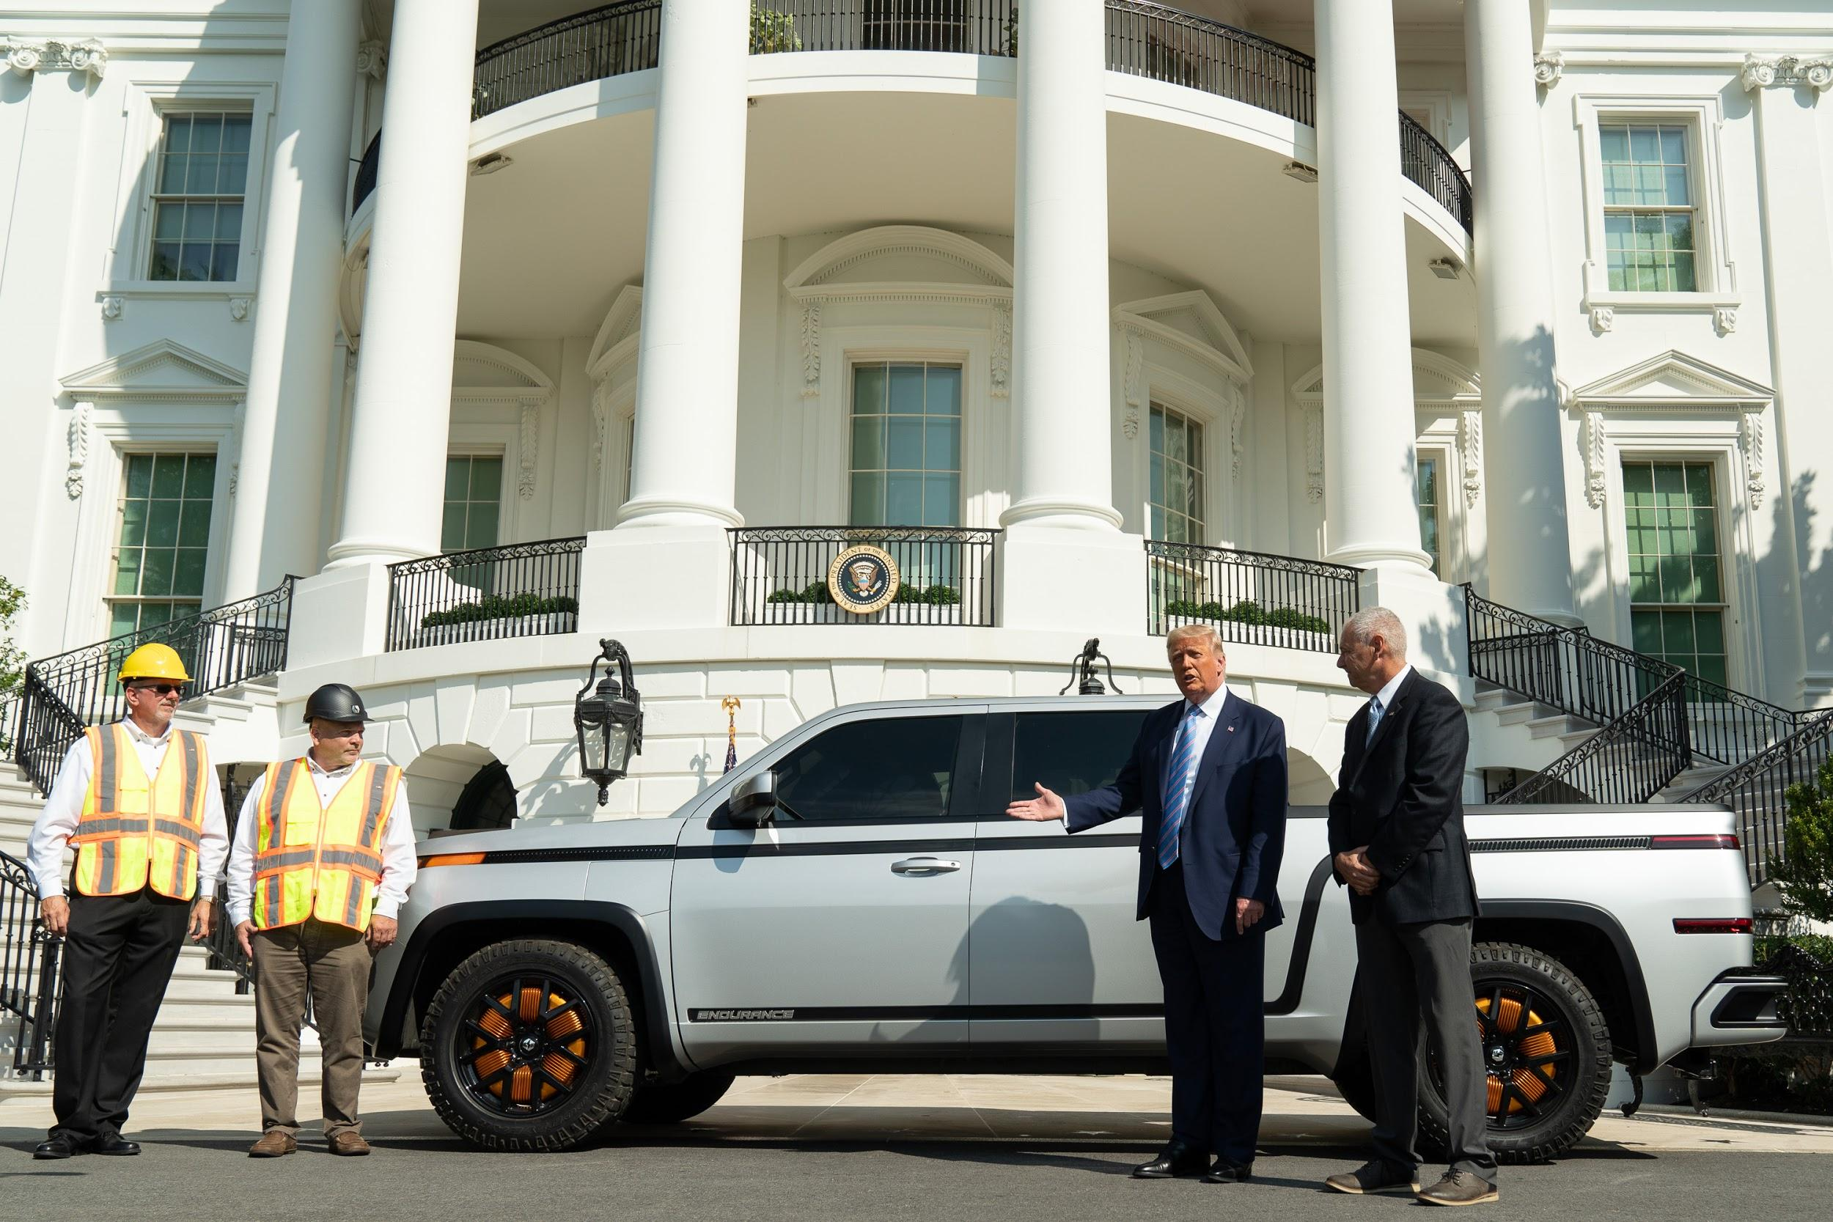 | 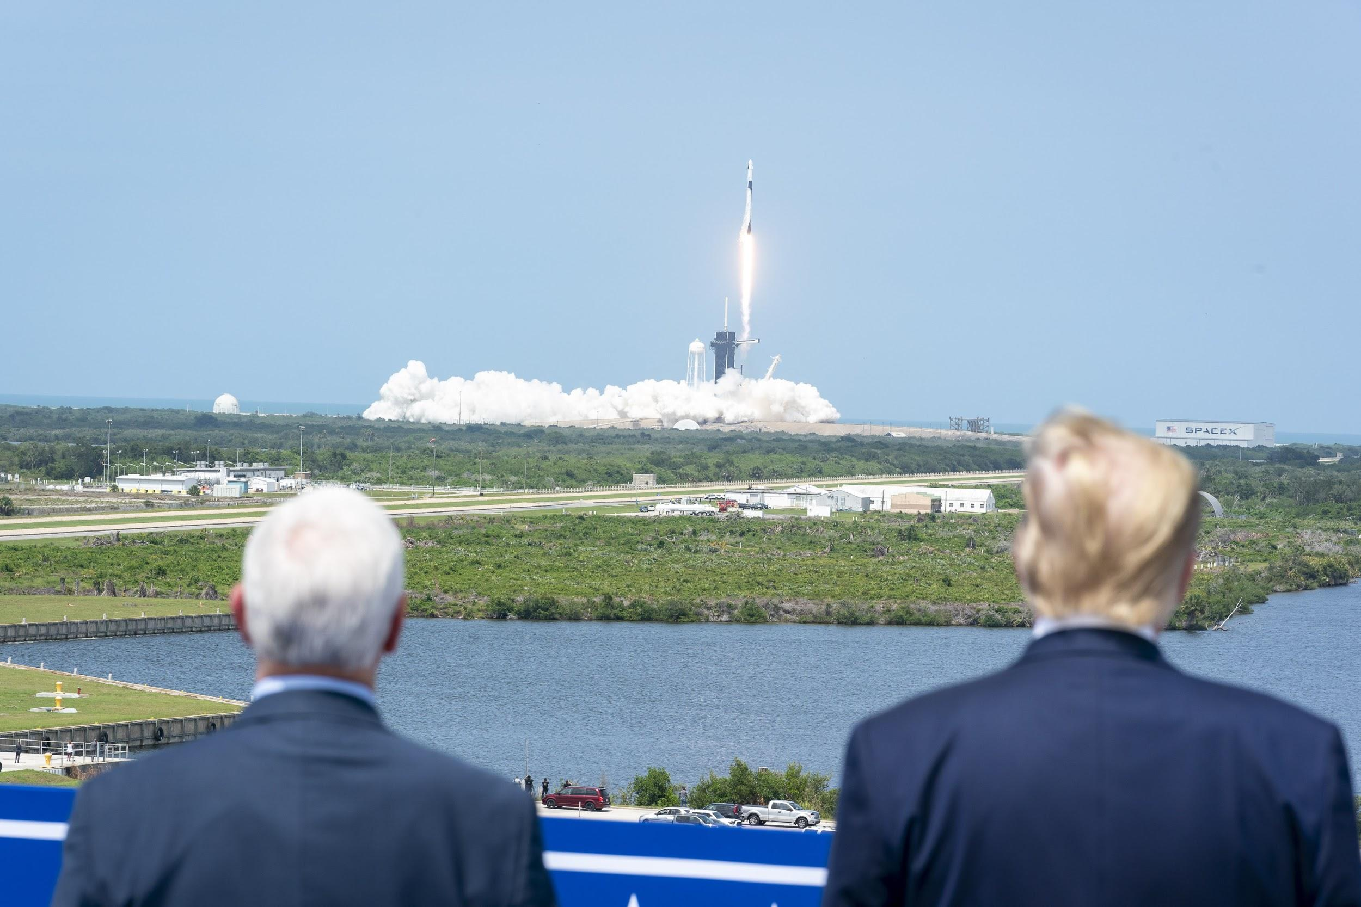
Fig. 9. Craighead, Shealah. “President Trump Tours a Lordstown Motors 2021 Endurance.” Flickr,  SmugMug Inc., 28 Sept. 2020, https://www.flickr.com/  photos/whitehouse/50397188968/. | Fig. 10. Craighead, Shealah. “SpaceX Demonstration Mission 2 Launch.” Flickr, SmugMug Inc., 20 May  2020, https://www.flickr.com/photos/whitehouse/  49963535768/.
In Figure 9, for instance, Trump is shown touring an electric truck from e-vehicle startup Lordstown Motors in September (The White House, 2020). In Figure 10, Trump and Vice President Pence are shown watching a SpaceX shuttle launch in May (The White House, 2020). Still, however, these images only reference a set of ideological terms in a secondhand manner; neither the form of the shuttle nor the truck are used with enough regularity, specificity, or contextual nuance to constitute ideographic terms in and of themselves. Moreover, a particular brand of truck and a SpaceX shuttle may be too specific to meet McGee’s standards that an ideograph be found in a common-language term adapted to political jargon (1980). Another form, however, remains consistent throughout the vast majority of the account’s imagery. It also remains a common-language visual term, one that is accessible to any audience but is used in disparate ways depending on the ideologies of those audiences. This term is linked to the aforementioned ideological themes with enough frequency that it could become ideologically refined with each use: the form of the president himself.
In originating as a commonly-used term and referencing complex ideologies, Trump’s form may meet Edwards and Winkler’s suggested qualifications for the visual ideograph, even though his image as an individual is representationally different from more complex cartoons which Edwards and Winkler first identified as utilizing such a term (1999). The use of a particular person’s form as an ideograph is not unheard of, however: in their 2020 analysis of visual commentary on the Kavanaugh hearings, Stassen and Bates discovered that visual depictions of then-Supreme Court Nominee Brett Kavanaugh bore enough ideological weight to constitute an <angry white man>, even as they denoted one individual in particular. Stassen and Bates identified the visual representations of Kavanaugh’s figure as they were utilized by public online communities, particularly on internet forums. It was at these locations that Kavanaugh was being associated with “synchronic and historical diachronic culture-bound abstractions of whiteness and masculinity,” which would ultimately allow his figure to “express collective commitments...guide behavior, and warrant patterns of power” (Stassen & Bates, 2020). They concluded that:
Memes featuring the image of Brett Kavanaugh, at a surface level, serve as a defense or indictment of Kavanaugh’s qualifications for a seat on the bench of the Supreme Court. These memes, however, are also a reflection of the contemporary political environment in which Kavanaugh was nominated. These memes help construct our understandings of the environment. (Stassen & Bates, 2020)
Trump’s form, as it is presented in the White House account’s photography, satisfies many of the same conditions used to determine the difference between Kavanaugh and the <angry white man>. Both images are presented and associated with ideological references (grand machinery and spaces in Trump’s case, among others; beer and college accoutrement in Kavanaugh’s) in a way that reflects a specific perspective of the contemporary political environment, which in turn could allow audiences to construct and justify ideology and action in relation to that environment. Despite these similarities, these two ideographs are dissimilar in regard to the authority of the rhetors using them. In the case of President Trump’s form on Flickr, the image is not being presented in locales led by the public, nor is it being so pointedly associated with community-defined abstractions as one would find in online memes. Instead, Trump’s form is being issued from a position of political power.
In his original scholarship on the ideograph, McGee noted that ideographic terms can be distributed and defined by politically influential rhetors rather than the public alone; McGee claimed, however, that while the use of such terms cannot control the public outright, it can condition the public “to a vocabulary of concepts that function as guides, warrants, reasons, or excuses for behavior and belief” (1980). McGee argued that those in power disseminate and influence ideographic language in order to persuade individuals toward a particular, actionable understanding of the world, even though they themselves also remain subject to the influence of these terms. Due to their broad accessibility and influence, then, McGee’s ideographs are not only to be defined and used by either the public or those in power. Rather, they are used and adjusted by both. In the case of Trump’s form as it is visible on the White House Flickr account, we do not see how the image is used and defined by the public as with the <angry white man>; instead, we can see how its creators link and separate Trump’s form as a visual term from other ideologies, perhaps in the hope that in time this form will be accepted and utilized by their public audience.
As McGee established, ideographs are defined as they are correlated with and distinguished from other ideas (1980). In the case of President Trump's form, we have already seen how it is connected to ideology through forms of consumer machinery, approving audiences, and spectacular spaces. However, one of the more influential relationships at play in the creation of this nascent ideograph, in the particular case of the Flickr account, is the context in which these photographs were taken. The Flickr account bears unique chronological significance due not only to its consistent annual growth, but also the explicit relationship between each of the images and the date at which they were taken and uploaded, dates which are recorded and linked to each photo on the account. Consider, again, Figure 10, the image of President Trump at the SpaceX launch in May. There, Trump’s form looks forward to a symbol of American commerce and innovation. The visual association between Trump and this shuttle performs an argumentative function, such as that proposed by Schill, when considering the photography from a purely political context: it links Trump to the progress connoted by the launch (2012). In addition, however, it serves another political function by providing a political record of a unique point in time for the country and Trump’s engagement with that period (Schill, 2012). Just five days before Figure 10 was taken, George Floyd was killed by a police officer in Minneapolis, resulting in several days of rising tensions both in that city and across the nation as protesters called attention to the police brutality which led to Floyd’s murder. Only one day before the photo was taken, Trump himself had threatened the protesters via Twitter, writing that “...when the looting starts, the shooting starts” (Sprunt, 2020). No visual reference to these protests would be made on the Flickr account until two days after the SpaceX photo was shot, amid rising tensions around the executive mansion due to an increase in protesting in the area. On June 1, 2020, Trump would pose outside of St. John’s Church just across from LaFayette square in D.C., with the White House photography team cataloguing the president’s walk across the square and toward the church (The White House, 2020).
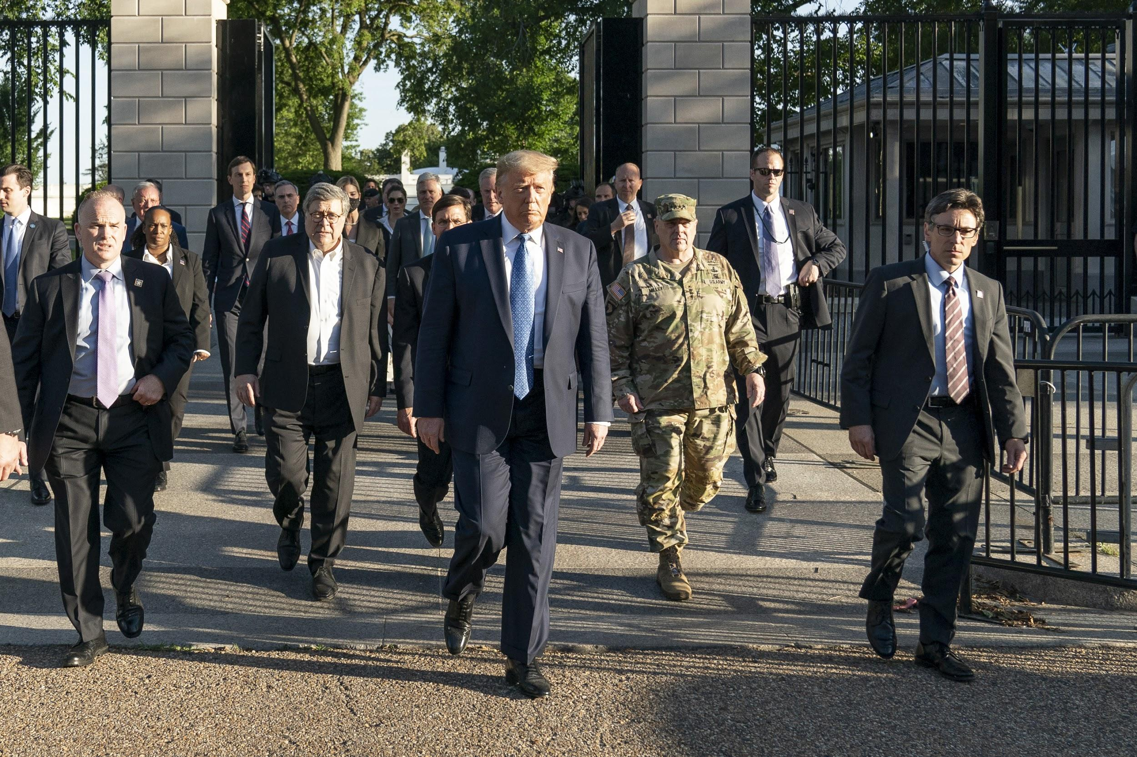 | 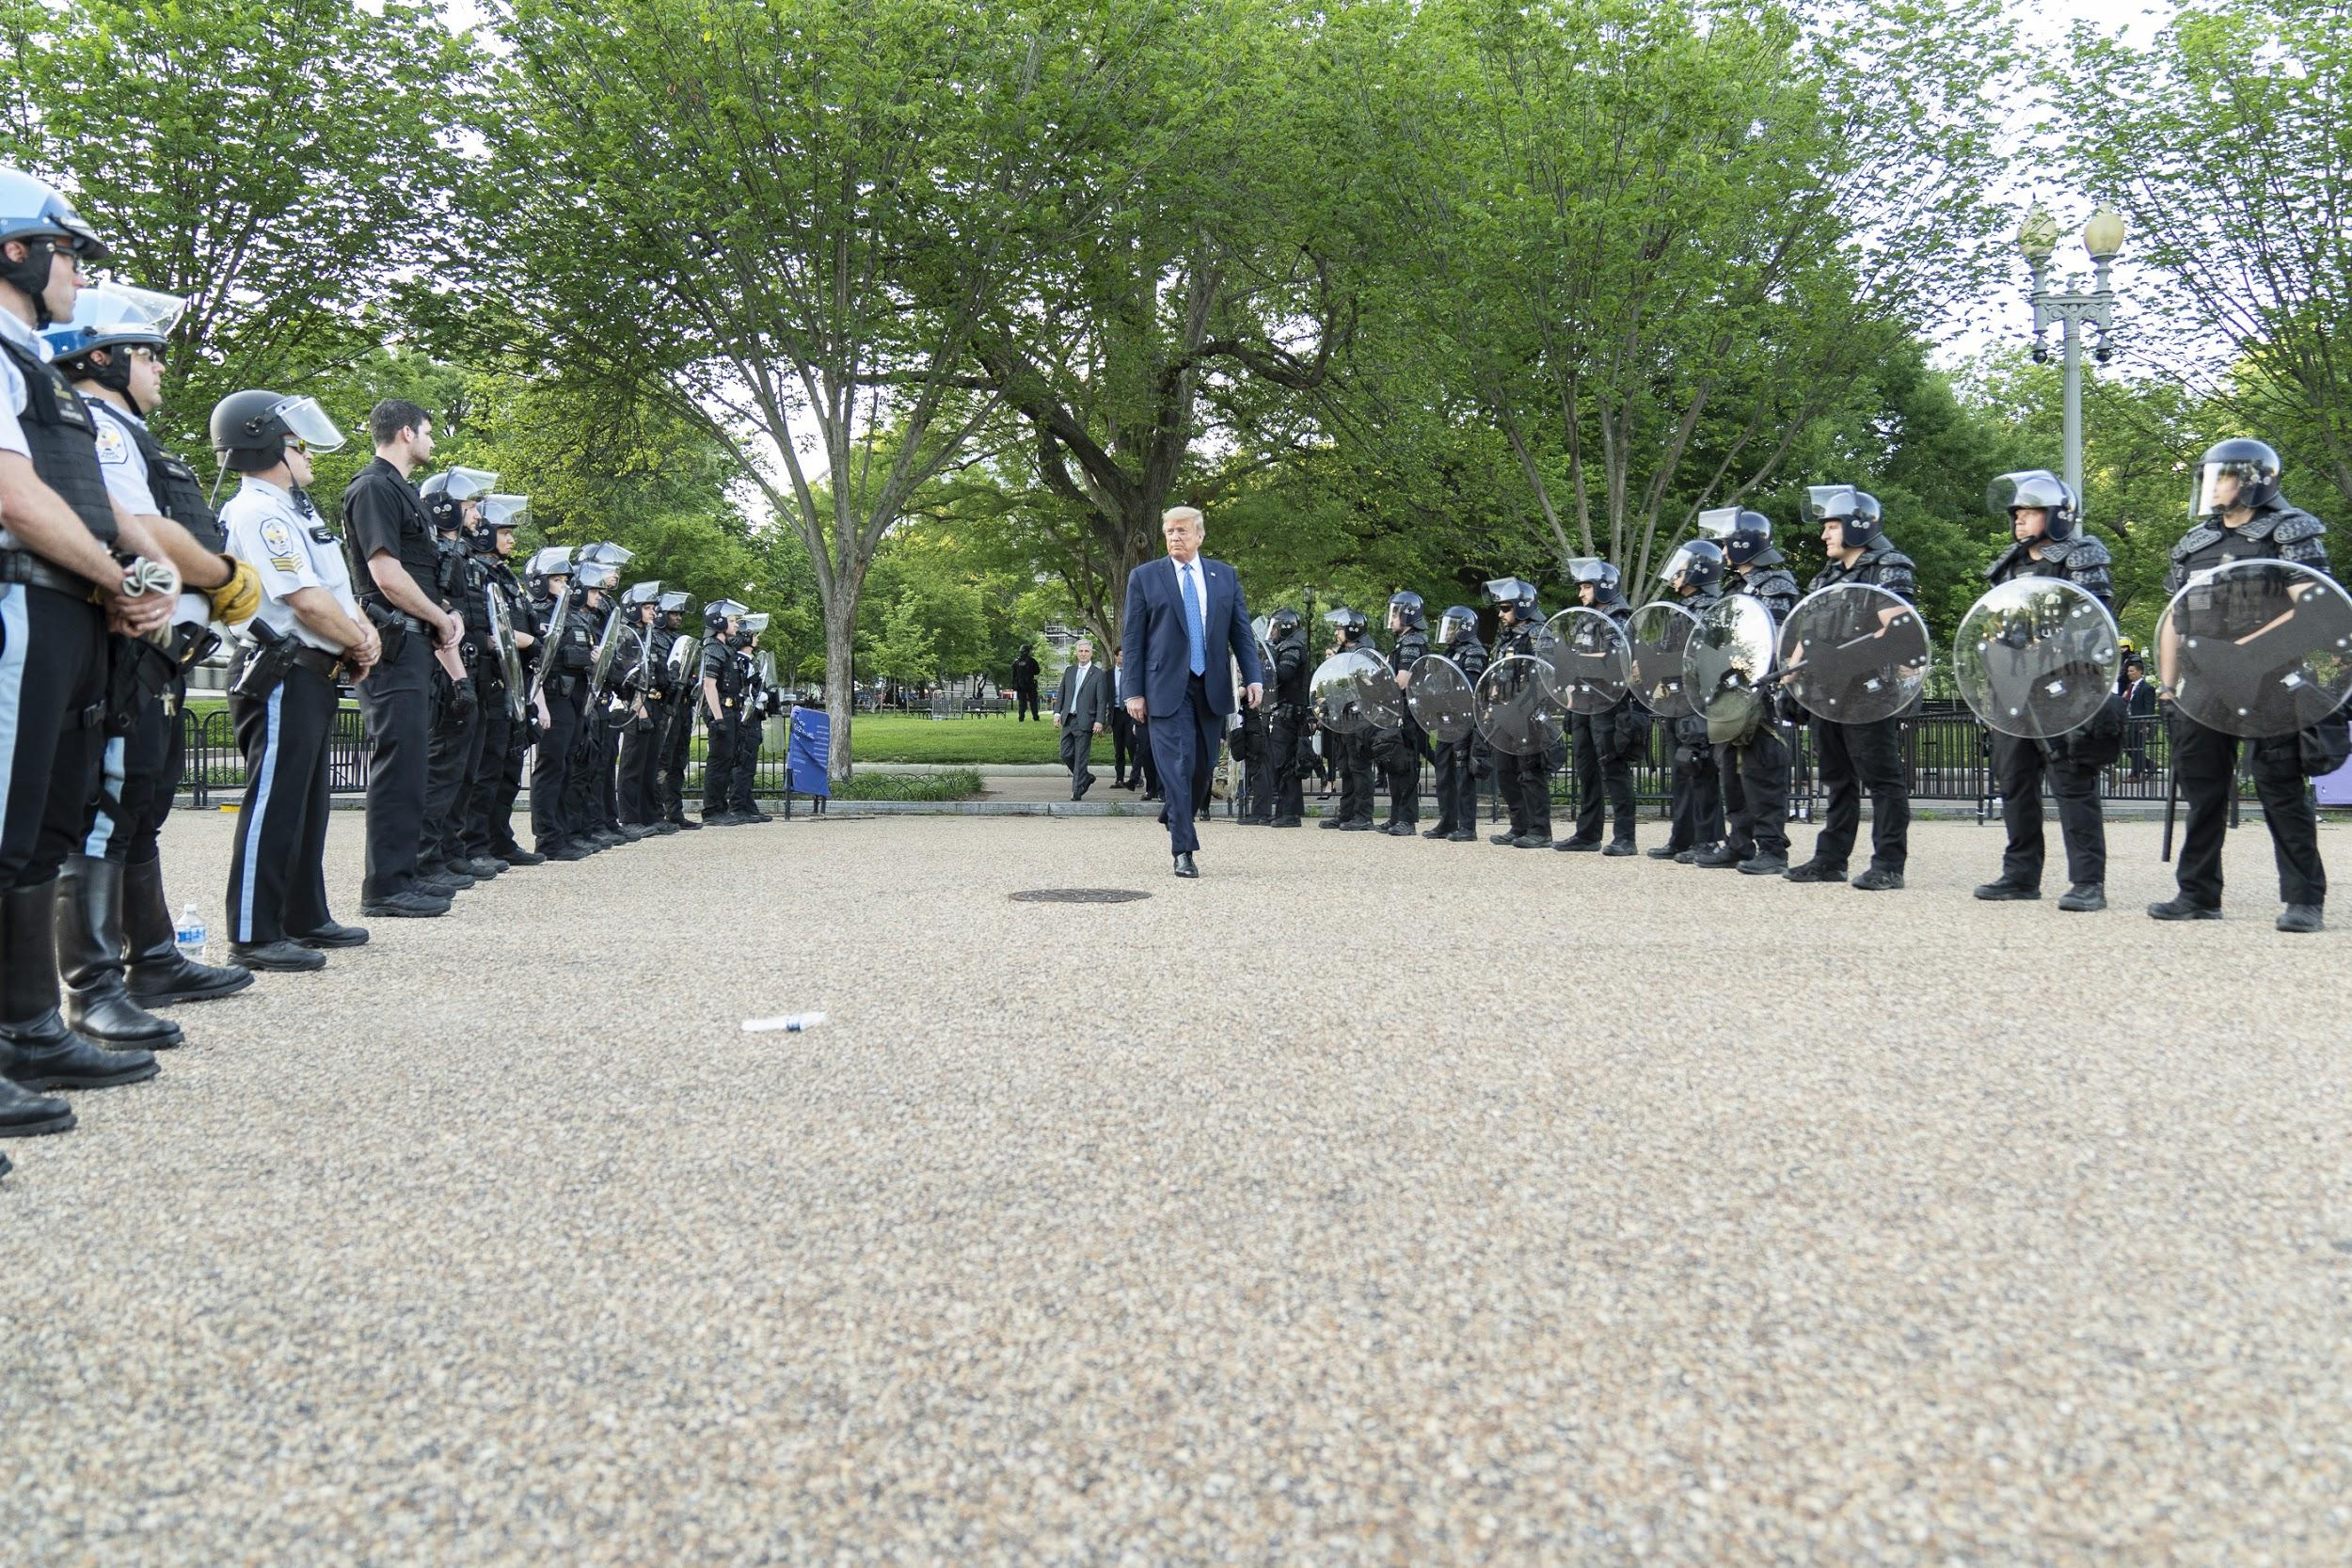
Fig. 11. Craighead, Shealah. “President Trump Visits St. John’s Episcopal Church.” Flickr, SmugMug  Inc., 1 June 2020, https://www.flickr.com/photos/  whitehouse/49964153176/. | Fig. 12. Craighead, Shealah. “President Trump Visits St. John’s Episcopal Church.” Flickr, SmugMug  Inc., 1 June 2020, https://www.flickr.com/photos/  whitehouse/49964436272/.

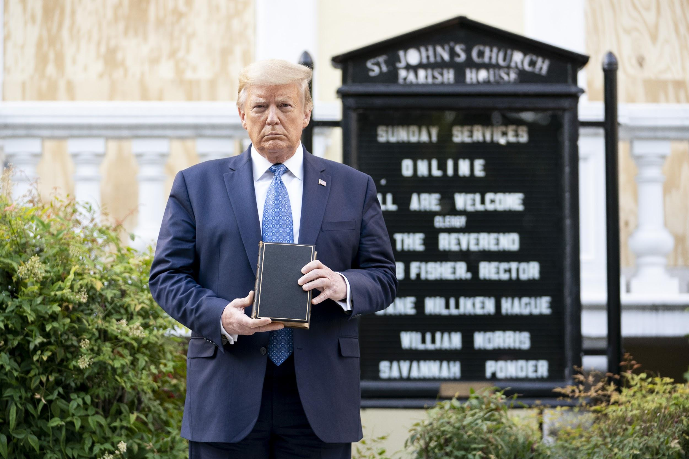
Fig. 13. Craighead, Shealah. “President Trump Visits St. John’s Episcopal Church.” Flickr, SmugMug
Inc., 1 June 2020, https://www.flickr.com/photos/whitehouse/49963649028/.
In Figure 11, Trump is portrayed walking with an entourage of executive officials, some in full military dress. In Figure 12, he is seen walking alone, guarded between lines of riot police at the ready with shields and batons (The White House, 2020). Finally, in Figure 13, Trump poses before the church in question, with Bible in hand and barricaded windows at his back . Trump’s visual association with the Bible, the police, and his executive cohort does much to rhetorically shape his form: he bears the full legal <strength> of his office through those who follow him as he is en route; he affirms and is affirmed by <law and order> as the police line his path; he protects and presents <faith> through his use of the Bible and the church behind him as final setpieces. Yet, these associations are far from the only potent influences on the ideological definition of his image. Consider, instead, images of the scene in LaFayette square just minutes before the above images were taken:
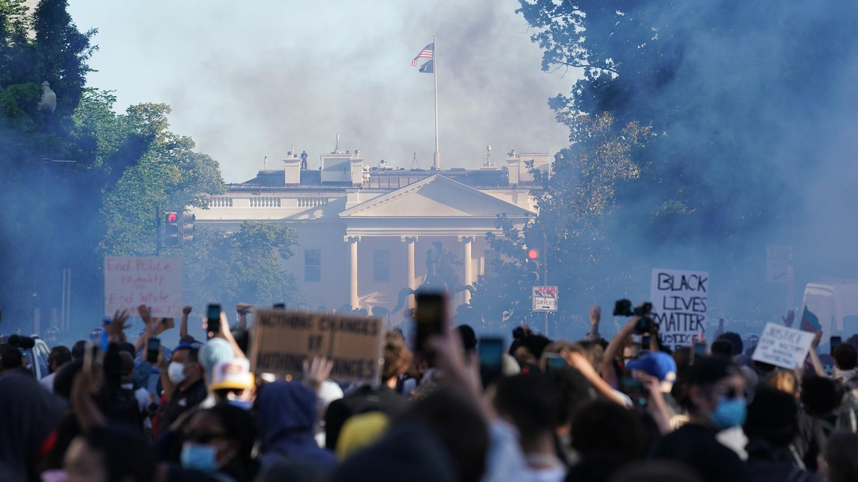
Fig. 14. Schaff, Erin. Image of protesters at Lafayette Square. The New York Times, The New York
Times., 1 June 2020, https://static01.nyt.com/images/2020/06/01/nyregion/
01blog-teargas/01blog-teargas-superJumbo-v2.jpg?quality=90&auto=webp.
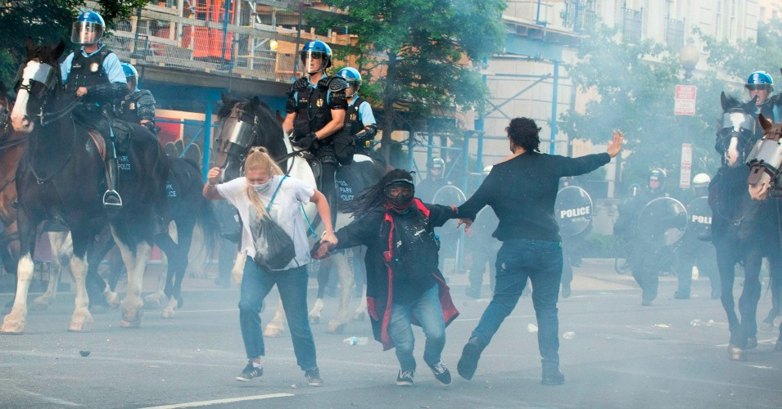
Fig. 15. Schmidt, Roberto. Image of riot police and protesters at Lafayette Square. The Washington Post, WP Company, 1 June 2020, https://www.washingtonpost.com/resizer/
RQgP9iWL6PLfliGz0PJRSvEgfuQ=/800x450/www.washingtonpost.com/r/2010-2019/WashingtonPost/2020/06/01/Interactivity/Images/crop_90AFP_1SO9Q4.jpg.
Absent from the Flickr account is any visual mention of those symbols which the president’s ideology does not condone. The ideological referents of these events and their actors—signs stating “Black Lives Matter” and facemasks reflecting the ongoing pandemic—are unseen; yet while they are omitted from these photographs, their influence on the representation of the president remains. In his scholarship on the semiotic interplay between ideographs and silence, Eric Connelly provides a succinct explanation for the phenomenon that may result when ideology, signification, and omission play central roles in a single rhetorical event:
Language that brackets a silence can exercise influence over its potential meaning because terms, particularly those that encompass ideological freight, can persuade a specific construction of meaning. Audiences fill in their expectations from the rhetorical context, with community-understood norms central to the process. (Connelly, 2012)
To the extent, then, that ideological signs are omitted by the Flickr account’s photographs, particularly due to their potential capacity as historical artifacts of presidential record, the audience is left to construct its own ideological reality of these events and the president within them—if not the country at large. <Faith>, <strength>, and <law and order> become amplified and refined as signifiers in the case of the photographs from July 1st, because the audience has the opportunity to interpret these values as superseding alternative ideologies. Less ostensibly, the imagery from the SpaceX launch on May 30th, in Figure 10, serves the same function, as what is presented in the image is Trump’s visual association with American <industry> and <progress>, and as Schill proposed, the omitted reality of nationwide protests and historic unrest permits the audience to evaluate its presented ideologies with greater, more nuanced potency (2012).

Conclusions and Future Research
This ideographic analysis has found that the photography available on the Flickr account of the Trump administration employs visual rhetoric which ideographically complicates the representative form of the president. When the imagery surrounding President Trump on the account omits ideological messaging from its content, his form is not only being positively complicated through the use of synchronic association with what is there. It is, in addition, being synchronically refined through ideological dissociation.
The form of the president, as it is altered through this process, meets the qualifications of ideograph formation and definition as first established by McGee: the term is being influenced, refined, and primed for public use by those in positions of power, even though they do not necessarily have complete control over the ideological influence of this term (1980). As with all ideographs, the term will be used and altered by the public as it is further placed in association with or contrast to other contemporary and historic ideological references. Despite this priming, audiences will still have the capacity to interpret the term differently according to the ideologies to which they ascribe. For Trump’s supporters, imagery of the president being associated with adoring crowds, spectacular and traditional settings, and symbols of military or industrial might will allow them not only to understand Trump’s form as promoting <strength> and <industry>, but to understand his form as promoting these things in context: despite all else that could be recorded by his office. An audience from the other side of the aisle, on the other hand, may look at that which is omitted and further define <Trump> as negligent due to their opposite ideological alignment. <Progress> and <industry> may even bear negative connotations for this group, which may instead refer to the <injustice> that could have been recorded at LaFayette square, or the COVID-19 crisis whose symptoms—facemasks, industrial burden, social distancing—required some sort of national diagnosis and <healing>, and went undisplayed. These ideologies are understood in the temporal negative space of the imagery, something presently available in the Flickr account medium due to its particular chronological consistency and relevance. It is through this account that the public has near instantaneous access to a visual presentation of the Trump administration’s perspectives on the country and the president within it; thereby, the public has the opportunity to watch, in the moment, as the visual form of the president is associated and recorded according to ideological symbols.
From that point, how and where <Trump> is utilized by the public at large as a term is one of many areas for potential research. As viral imagery becomes an ever more important medium in contemporary political discourse, one could surely provide analysis building off of this research, and that of Stassen and Bates, to determine how and why ideographs are defined and distributed among the online public. The broader topic of online virality is also increasingly significant as communication from the executive office has moved to a near constant flow of social media messaging. In their research, Campbell and Jamieson identified genres of presidential rhetoric particularly as they related to presidential speechcraft and formal public address, however, the question remains as to whether presidential rhetoric to the public—coming through a more generalized intermediary in the form of social networking media rather than through more traditional print media, for example—conforms precisely to these genres. Identifying if and how each artifact of online president-to-public rhetoric through avenues such as Flickr and Twitter conforms to these historic genres, or expands into new territory as a form of presidential speech, could reveal new understandings of the public’s perceptions and expectations of the executive office. Furthermore, researchers interested in Trump’s Flickr photography could perform more quantitative analyses of the account’s content, reminiscent of that conducted by Chun; a content analysis may reveal trends and adjustments in the emphasis of specific rhetorical themes in response to current events.

Works Cited

@realDonaldTrump (Donald Trump). “I will be leaving the great Walter Reed Medical Center
today at…” Twitter, 5 Oct. 2010, https://twitter.com/realdonaldtrump/status/
1313186529058136070?lang=en

Baker, Peter, et al. “How Trump's Idea for a Photo Op Led to Havoc in a Park.” The New York
Times, The New York Times, 3 June 2020, www.nytimes.com/2020/06/02/us/
politics/trump-walk-lafayette-square.html.

Beasley, Vanessa B. “The Rhetoric of Ideological Consensus in the United States: American
Principles and American Pose in Presidential Inaugurals.” Communication Monographs, vol. 68, no. 2, 2001, pp. 169–183.

Bennett, Dalton, et al. “The Crackdown before Trump's Photo Op: How Law Enforcement
Cleared Protesters Outside the White House.” The Washington Post, WP Company, 8 June 2020, www.washingtonpost.com/investigations/2020/06/08/
timeline-trump-church-photo-op/?arc404=true.

Brummett, Barry. “Towards a Theory of Silence as a Political Strategy.” Quarterly Journal of
Speech, vol. 66, no. 3, Oct. 1980, pp. 289–303.

Campbell, Karlyn Kohrs, and Kathleen Hall Jamieson. Presidents Creating the Presidency:
Deeds Done in Words. The University of Chicago Press, 2013.

Connelly, Eric. “State Secrets and Redaction: The Interaction between Silence and Ideographs.”
Western Journal of Communication, vol. 76, no. 3, 2012, pp. 236–236.

Chappell, Bill. “'Enormous And Tragic': U.S. Has Lost More Than 200,000 People To
COVID-19.” NPR, NPR, 22 Sept. 2020, www.npr.org/sections/coronavirus-live-updates/
2020/09/22/911934489/enormous-and-tragic-u-s-has-lost-more-than-200-000-people-to-covid-19.

Chun, Russell Scott. “Visual Rhetoric of the Presidency: An Analysis of the Trump and Obama
White House Messaging in Their First 100 Days in Flickr Images.” Journal of Visual
Literacy, vol. 37, no. 1, 2018, pp. 18–39.

Edwards, J. L, and C. K Winkler. “Representative Form and the Visual Ideograph: The Iwo Jima
Image in Editorial Cartoons.” Communication Abstracts, vol. 21, no. 2, 1998.

Grabe, Maria Elizabeth, and Erik Page Bucy. Image Bite Politics : News and the Visual Framing
of Elections, Oxford University Press, Incorporated, 2009. ProQuest Ebook Central, https://ebookcentral.proquest.com/lib/berry/detail.action?docID=415422.

Groner, Danny. “Barack Obama and the Flickr Presidency.” U.S. News & World Report,
10 Dec. 2012, www.usnews.com/opinion/articles/2012/12/10/how-the-obama-white
-house-uses-flickr-to-tell-its-story-.

Hariman, Robert, and John Louis Lucaites. “Photography: The Abundant Art.” Photography and
Culture, vol. 9, no. 1, 2016, pp. 39–58.

Kelly, Casey Ryan. “Donald J. Trump and the Rhetoric of Ressentiment.” The Quarterly Journal
of Speech, vol. 106, no. 1, 2020, pp. 2–24.

“Live Oregon, California, and Washington Fires Updates.” The New York Times, The New York
Times, 17 Sept. 2020, www.nytimes.com/2020/09/17/us/wildfires-live-updates.html.

Lucaites, John Louis, and Celeste Michelle Condit. “Reconstructing <Equality>: Culturetypal
and Counter-Cultural Rhetorics in the Martyred Black Vision.” Communication Monographs, vol. 57, no. 1, 1990, pp. 5–5.

McGee, Michael Calvin. “The ‘Ideograph’: A Link between Rhetoric and Ideology.”
Quarterly Journal of Speech, vol. 66, no. 1, 1980, pp. 1–16.

Morales, Christina, et al. “A Timeline of Trump's Symptoms and Treatments.” The New York
Times, The New York Times, 4 Oct. 2020, www.nytimes.com/2020/10/04/us/
trump-covid-symptoms-timeline.html.

Morris, Errol. “Anatomy of a Photograph: Authoritarianism in America.” The Atlantic, The
Atlantic Monthly Group, 22 Aug. 2020, www.theatlantic.com/ideas/archive/2020/08/
errol-morris-this-is-what-authoritarianism-looks-like/615181/.

O'Kane, Sean. “The Photography of Trump's Presidency Is a Huge Break from Obama's.”
The Verge, Vox Media, 2 Apr. 2017, www.theverge.com/2017/4/2/15140892/
trump-white-house-photographer-shealah-craighead-vs-pete-souza-obama.

Samenow, Jason, et al. “2020 Atlantic Hurricane Season Breaks All-Time Record While Leaving
Gulf Coast Battered.” The Washington Post, WP Company, 10 Nov. 2020, www.washingtonpost.com/weather/2020/11/10/record-hurricane-season-atlantic/.

Schill, Dan. “The Visual Image and the Political Image: A Review of Visual Communication
Research in the Field of Political Communication.” Review of Communication, vol. 12,
no. 2, 2012, pp. 118–142.

Shaw, Michael. “11 Images That Show How the Trump Administration Is Failing at
Photography.” Columbia Journalism Review, Columbia University, 25 Apr. 2017, www.cjr.org/politics/trump-photography.php.

Sprunt, Barbara. “The History Behind 'When The Looting Starts, The Shooting Starts'.” NPR,
NPR, 29 May 2020, www.npr.org/2020/05/29/864818368/
the-history-behind-when-the-looting-starts-the-shooting-starts.

Stassen, Heather M, and Benjamin R Bates. “Beers, Bros, and Brett: Memes and the Visual
Ideograph of the <Angry White Man>.” Communication Quarterly, vol. 68, no. 3, 2020,
pp. 331–354.

The White House. “The White House.” Flickr, Yahoo!, 2020, www.flickr.com/photos/
whitehouse/.

Towner, Emil. “A <Patriotic> Apologia: The Transcendence of the Dixie Chicks.” Rhetoric
Review, vol. 29, no. 3, 2010, pp. 293–309.

Selected Photographs

Craighead, Shealah. “2020 Briefing on the Hurricane Season.” Flickr, SmugMug Inc., 28 May
2020, https://www.flickr.com/photos/whitehouse/49949230611/.

Craighead, Shealah. “President Trump at the Bioprocess Innovation Center at Fujifilm Diosynth
Biotechnologies.” Flickr, SmugMug Inc., 27 July 2020, www.flickr.com/photos/
whitehouse/50162729881/.

Craighead, Shealah. “President Trump Delivers Remarks at the North Carolina Opportunity Now
Summit.” Flickr, SmugMug Inc., 7 Feb. 2020, https://www.flickr.com/photos/
whitehouse/49503339221/.

Craighead, Shealah. “President Trump Delivers Remarks on the America First Healthcare Plan.”
Flickr, SmugMug Inc., 24 Sept. 2020, www.flickr.com/photos/whitehouse/50382649527/.

Craighead, Shealah. “President Trump in California.” Flickr, SmugMug Inc., 14 Sept. 2020,
www.flickr.com/photos/whitehouse/50344668423/.

Craighead, Shealah. “President Trump Tours a Lordstown Motors 2021 Endurance.” Flickr,
SmugMug Inc., 28 Sept. 2020, https://www.flickr.com/photos/whitehouse/50397188968/.

Craighead, Shealah. “President Trump Visits St. John’s Episcopal Church.” Flickr, SmugMug
Inc., 1 June 2020, https://www.flickr.com/photos/whitehouse/49964153176/.

Craighead, Shealah. “President Trump Visits St. John’s Episcopal Church.” Flickr, SmugMug
Inc., 1 June 2020, https://www.flickr.com/photos/whitehouse/49964436272/.

Craighead, Shealah. “President Trump Visits St. John’s Episcopal Church.” Flickr, SmugMug
Inc., 1 June 2020, https://www.flickr.com/photos/whitehouse/49963649028/.

Craighead, Shealah. “SpaceX Demonstration Mission 2 Launch.” Flickr, SmugMug Inc., 20 May
2020, https://www.flickr.com/photos/whitehouse/49963535768/.

Dufour, Tia. “President Trump Works at Walter Reed National Military Medical Center.” Flickr,
SmugMug Inc., 4 Oct. 2020, https://www.flickr.com/photos/whitehouse/50423967302/.

Dufour, Tia. “White House Press Briefing.” Flickr, SmugMug Inc., 16 Sept. 2020,
https://www.flickr.com/photos/whitehouse/50352466851/.

Hanks, Andrea. “President Trump and the First Lady in India.” Flickr, SmugMug Inc., 24 Feb.
2020, https://www.flickr.com/photos/whitehouse/49583714032/.

Schaff, Erin. Image of protesters at Lafayette Square. The New York Times, The New York
Times., 1 June 2020, https://static01.nyt.com/images/2020/06/01/nyregion/
01blog-teargas/01blog-teargas-superJumbo-v2.jpg?quality=90&auto=webp.

Schmidt, Roberto. Image of riot police and protesters at Lafayette Square. The Washington Post,
WP Company, 1 June 2020, https://www.washingtonpost.com/resizer/
RQgP9iWL6PLfliGz0PJRSvEgfuQ=/800x450/www.washingtonpost.com/r/2010-2019/WashingtonPost/2020/06/01/Interactivity/Images/crop_90AFP_1SO9Q4.jpg.

This follower estimate was made using the official White House Instagram and Facebook accounts in addition to the @realDonaldTrump Twitter account, as it is the primary account used by the president.
In-text citations of this source will refer to information that was gleaned from The White House account’s photo descriptions, which contain contextual information such as the location and figures depicted in the photographs, yet have no listed author.
See Morris’s analysis of this event in his article “Anatomy of a Photograph: Authoritarianism in America,” from The Atlantic, which served as one of the primary inspirations for this paper.

