April 9, 2012, 9:00 pm
http://opinionator.blogs.nytimes.com/2012/04/09/fanfare-for-the-comma-man/

Fanfare for the Comma Man
By BEN YAGODA
Draft is a series about the art and craft of writing.

Tags:
comma, Writing

Is it safe to talk about punctuation again? Eight years ago, Lynne Truss’s best-selling “Eats, Shoots & Leaves” took, in the words of her subtitle, a “Zero Tolerance Approach” to the subject. Although Truss’s focus on errors drew the ire, if not the fire, of grammarians, linguists and other “descriptivists,” her book was, for the most part, harmless and legitimate. Still, it overlooked a lot. Maybe more than any other element of writing, punctuation combines rules with issues of sound, preference and personal style. And as Truss didn’t adequately acknowledge, even the rules change over time.

The two big players in the field are the period and the comma. I’ll start with the latter because the protocol for comma use is so complicated and contingent. As I said, what’s right and wrong changes historically, and the comma shows this clearly. In the 19th century and earlier (when rules were generally more lax than they are today), comma use was pretty much a crapshoot. That is, writers rolled one in when they felt like it, which was usually when a natural pause seemed to occur. So in the first line of “Pride and Prejudice” (1813), Jane Austen wrote:

“It is a truth universally acknowledged, that a single man in possession of a good fortune, must be in want of a wife.”

By about a century later, comma rules had been codified such that both commas in the sentence (after “acknowledged” and “fortune”) would be dispensed with.

You can glimpse a reason for this codification — which emphasized consistency rather than sound — by looking at the opening of the Second Amendment of the Constitution (1789):

A well regulated Militia, being necessary to the security of a free State, the right of the people to keep and bear Arms, shall not be infringed.

There are three commas. The one after “state” would be used today; the one after “arms” would not; the one after “militia” is ambiguous; and all three have caused a world of hurt, confusion and argumentation over the last 223 years. As Adam Freedman wrote in this newspaper in 2007, a Federal District Court ruling invalidating the District of Columbia’s gun ban (subsequently upheld by the Supreme Court) held that “the second comma divides the amendment into two clauses: one ‘prefatory’ and the other ‘operative.’ On this reading, the bit about a well-regulated militia is just preliminary throat clearing; the framers don’t really get down to business until they start talking about ‘the right of the people … shall not be infringed.’” More generally, the funky comma protocol muddies the crucial link between the importance of militias and the right of people to bear arms.

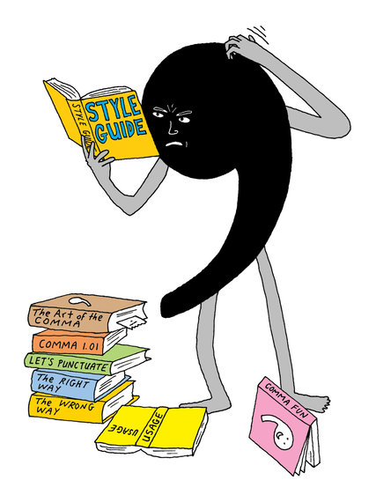

As a professor at the University of Delaware, I read a lot of writing by college students, and in it a strong recent trend is reversion to comma-by-sound. I attribute this not so much to students’ love of the Constitution and the classics but to the fact that they don’t read much edited prose (as opposed to Facebook status updates, tweets and the like). Two things that you really need to read a lot to understand are punctuation and spelling. (Not coincidentally, spelling is the other contemporary writing disaster.)

As far as comma use goes, my students play it by ear. I see this most dramatically in sentences that start with conjunctions like “And,” “But” and “So.” (Your junior high school English teacher may have told you never to start a sentence with a conjunction. To the extent that was once true, it isn’t anymore.) So students will write sentences like this:

So, students will write sentences like this.

But, they are wrong.

You see this kind of thing all over the Internet as well. People punctuate that way because, if they spoke these sentences, they’d pause after the conjunction (and because the extremely fanciful and undependable Microsoft Word grammar and style checker refrains from applying a squiggly green underline).

My students are, not illegitimately, making a grammatical transformation as well: turning the conjunctions into what are called “sentence adverbs” — words like “Presumably,” “However” and, yes, “Hopefully” that are followed by commas when they start sentences. Punctuation rules may and probably will change accordingly. But they haven’t yet, and I tell my students to lose the comma.

This brings up a key question: Who decides when and how punctuation rules change? The short answer is, no one. The longer answer is that presumably and eventually, the editors of “The Associated Press Stylebook” and “The Chicago Manual of Style,” and the worthies who decide such matters for The New York Times, the Modern Language Association and a few other enterprises reach a consensus on these matters, and their decisions filter down to the rest of us.

I said earlier that personal preference and style play a big role in punctuation use, and this applies to some aspects of comma-by-sound. A modifying or transitional phrase at the beginning of a sentence can be followed by a comma or not, depending on your personal style, the meaning of the particular sentence and the length of the phrase.

So would you put a comma in the following sentences?

By this time tomorrow I’ll be in Poughkeepsie.

Generally speaking the Republicans win the Western states.

Late at night the visibility can get pretty bad.

There’s no right answer! It’s up to you! But you can see that the comma-less versions are no-nonsense and a bit brusque. With the comma, the feel is more deliberate and old-fashioned.

If you’re writing for publication, something else that comes into play is house style. This is seen most famously in the so-called Oxford comma — the one that goes after the second-to-last item in a series. Referring to the Philadelphia Phillies outfield as “Pence, Victorino and a left fielder-by-committee” would be fine in this newspaper but not in The New Yorker, which would change it to “Pence, Victorino, and a left fielder-by-committee.”

The New Yorker has always been scrupulous, bordering on fetishistic, about commas, in large part because of its founder Harold Ross’s mania for precision and clarity. E.B. White, who was subject to the magazine’s editing for more than five decades, remarked in a Paris Review interview, “Commas in The New Yorker fall with the precision of knives in a circus act, outlining the victim.” There are many examples, but one particular comma use is consistently and pretty much only found in The New Yorker. An example is a sentence from an article by Jane Mayer in the double issue dated Feb. 13 and 20:
Before [Lee] Atwater died, of brain cancer, in 1991, he expressed regret over the “naked cruelty” he had shown to [Michael] Dukakis in making “Willie Horton his running mate.”
No other publication would put a comma after “died” or “cancer.” The New Yorker does so because otherwise (or so the thinking goes), the sentence would suggest that Atwater died multiple times and of multiple causes.

That is nutty, of course. But it has a certain charm as well, expressing as it does a whole approach to the world. And it’s all because of the comma.

Ben Yagoda is a professor of English at the University of Delaware and the author of, among other books, “About Town: The New Yorker and the World It Made” and “The Sound on the Page: Style and Voice in Writing.” He blogs for the Chronicle of Higher Education and his own blog, Not One-Off Britishisms. His forthcoming book is “How to Not Write Bad.”

This post has been revised to reflect the following correction:

Correction: April 11, 2012
An earlier version of this article misstated the length of time E.B. White wrote for The New Yorker as five centuries.

